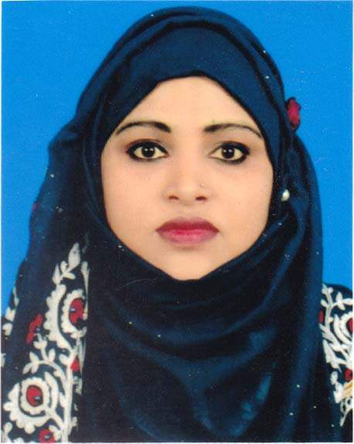
CURRICULUM VITAE OF

Khathiza Begum

NazirChowdury house, Ghilatoli , Whaikong,

Teknaf, Cox’s Bazar

Mobile: +880 1757199907,880 1877570573

Email: khathizabegum85@gmail.com

Career Objective

To work with maximum potential in a challenging and dynamic environment with team of professional to give out my best and enhance my professional skill through learning and experience sharing
Career Summary
I possess more than 5 years’ experience of working in different organization whereby I have developed my skills in Protection issues, SGBV, WASH in the context of Rohingya crisis. My ability to adapt to any situations and being of sober nature enables me to mingle with any team very quickly. Looking at the current scenario where girls are victims of various exploitations, I intend to be associated with actors who are working towards women’s empowerment.
Summary of Qualifications /Skills
- Outstanding experience in organizing public motivational session
- Excellent analytical, organizational, communication and interpersonal skills.
- Experience in implement the materials purchase processing.
- Ability to work alone and on a team, problem analysis & solving capacity.
- Proficient in MS Office (Word, Excel, PowerPoint, Access, email, Internet browsing.

Educational Qualification
Board/University | Subject/Major | Passing Year | Institute | Result
Bachelor of Arts (B A) | Humanities | Appeared | Govt. College Cox’s Bazar | Appeared
Higher Secondary Certificate (H.S.C) | Humanities | 2009 | Nasirabad CollegeMymensingh | 2.35 Out of 5
Secondary School Certificate (S.S.C) | Humanities | 2001 | Al Haz Ali Achiya High School | 2.25 Out of 5

Professional Experience/Background

Organization : ADRA Bangladesh CEARR Project
Designation : Safe Space Officer
Duration : November 15, 2018 - Continue.

The Major duties and responsibilities are as below:
- Supervising sessions conducted in CFS (Child Friendly Space) with the children and ensuring it is done in line with the guidelines for operating CFS.
- Conducting monthly meeting with parents of CFS Children to know their views for further improvement of the sessions.
- Work with adolescent girls in the WGSS to identify their needs, interests and priorities, provide information of various services being provided by other actors, and where possible, adapt activities according to the needs of the adolescent girls and women attending the WGSS(Women`s Girls Safe Space).
- Ensure activities offered are culturally appropriate and meet the needs of adolescent girls;
- Assist with dignity kit distributions, appropriate messaging, and feedback from adolescent girls on dignity kits and other discretionary items provided;
- Through the GBV session with adolescent girls and women, inform about available services and material support being provided by other actors in the camp.
- Share about the referral pathway service to all the participants during GBV Sessions and in WGSS.
- Provide Psychosocial First Aid and non-judgmental support and services to adolescent girls and victims of gender violence.
- Assist in the planning and implementation of activities aimed at community leaders and parents of the adolescent girls accessing the WGSS and safe spaces.
- Ensure proper maintenance of record of attendance and activities and support M& E activities as requested to support quality programming reporting.
- Conducting Watch Group meeting with male and adolescent girls.
- Keeping positive, productive, trusting relation with adolescent girls, their parents and their communities,
- Maintain professional boundaries and humanitarian ethics at all times.

Organization :Save The Children
Designation : Case Worker
Duration : September05, 2017- June30, 2018.

The Major duties and responsibilities are as below:
Responsibility Understanding the Role of a Case Worker .Being a case Worker is often a challenging,yet rewarding career.Case Worker are responsible for helping individuals, families and groups of people cope with problems that they are facing to improve their patients’ lives.Each case I take care of responsibly.

Language Proficiency
Language | Listening | Speaking | Reading | Writing
Bengali | Excellent | Excellent | Excellent | Excellent
English | Good | Good | Excellent | Good
Cox’s Bazar Local Language | Excellent | Excellent | Excellent | Excellent
Professional Training
Title | Major Topic | Duration | Provided by | Location
Protection from Sexual Exploitation and Abuse | How to verify PSEA in the Humanitarian Sector. | 2 Day | ADRA Bangladesh | Cox’s Bazar
Gender Equality | Human Rights | 4 Day | ADRA Bangladesh | Cox’s Bazar
Kobo Collection | How to collect Kobo and HH Survey, FGD Survey | 3 Day | ADRA Bangladesh | Cox’s Bazar
Gender Base Violence and Complain Mechanisms | Gender GBV and Complain Mechanisms | 3 days | ADRA Bangladesh | Cox’s Bazar
Gender Equality | Fafenist International Policy | 3 days | ADRA Bangladesh | Cox’s Bazar

Training:
Title | Major Topic | Duration | Provided by | Location
Project Development Monitoring (PDM) | Exercise on project proposal | 3 Day | ADRA Bangladesh | Cox’s Bazar
Computer Course Training | M/S Office | 3 Month | AIT | Cox’s Bazar

Personal Details:
Name : Khathiza Begum
Father’s Name : NazirHussain Chowdhury
Mother’s Name : KhayrunNesha
Date of Birth : March 04-1985
Sex : Female
Nationality : Bangladeshi
Marital Status : Married
Religion : Islam
Blood Group : B+
National ID No : 6125217235141
Present Address : Chowdoryhouse ,Ghilatoli, Whaikong
Taknaf, Cox’s Bazar.
Permanent Address : Chowdoryhouse ,Ghilatoli, Whaikong
Taknaf, Cox’s Bazar.

Particulars | Reference 01 | Reference 02 | Reference 03
Name | Sujon Chondro Das | Genuine Chakma | Salmon Sangma
Designation | Project Manager | Structural Engineer | Senior Accountant
Organization | ADRA CEARR Project | Danish Refugee Council | ADRA UNHCR Project
Mobile No | +880 1790 251673 | +880 1849 314881 | +880 1823 345176
Email Address | sujon@adrabd. org | genuinechakma4@gmail.com | salmon@adrabd.org
Reference :

I certify that all the information stated in this resume is true and complete to the best of my knowledge.
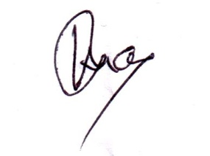

Khathiza Begum
Cell: +880 1757199907

