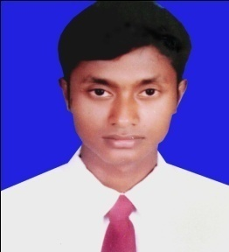
Curriculam VITAE
Of
Md.Rokibul Islam
Mobile: 01778-354545
Email:tanbinkhan56@gmail.com

CAREER OBJECTIV

I am looking forward tobuilld my career in any reputed and challenging position where I can prove my skills and abilities through hard work and professionalism with my team oriented or individual activity in a growth-oriented environment.

ACADEMIC QUALIFICATION

Diploma in Civil engineering:
Discipline: Civil Technology.
Institute: Science Recherce & Techonlogy College Rajshahi.
GPA: 2.99 (Out of 4)
Year of Passing: 2015.
Board: Rajshahi.
Secondary School Certificate:
Discipline: Human.
School: Abul Hossain High School:
GPA: 3.56 (Out of 5).
Year of Passing: 2010.
Board: Rajshahi.

COMPUTER LITERACY

Application: & Office Program: MS Word, Adobe Photoshop, Internet Browsing, Auto
CAD (2D).

LANGUAGE LITERACY

English Skill: Speaking (Good), Writing (Good), Listening (Good).
Bengali Skill: Speaking (Fluent), Writing (Fluent), Listening (Fluent).

MAILING ADDRESS
Present:
Name: Md. Rokibul Islam.
C/O: Md. Fuzlul Haque.
Vill: Cher Shahapur.
PO: Dher Shahapur.
Thana: Ishwardi.
Dist: Pabna.
Permanent:
Name: Md. Rokibul Islam.
C/O: Md. Fuzlul Haque.
Vill: Cher Shahapur.
PO: Dher Shahapur.
Thana: Ishwardi.
Dist: Pabna
PROFILE
Name: Md. Rokibul Islam.
Father’s Name: Md. Fazlul Haque.
Mother’s Name: Most. Ambia Begum.
Date of Birth: 10/05/1994.
Contact Number: 01750-893744
Nationality: Bangladeshi by Birth.
National ID No: 19947613963000047.
Marital Status: Unmarried.
Religion: Islam (Sunni).
Blood Group: B+
Height: 5.6”(Approx).
Weight: 55 Kgs (Approx).
TRAINING
I Have complete Industrial Attachment Programmer in Concord Group Limited.

Job Experience | - Company:Rupali Bank Sure Cash.  - Position: DO  - Location: Ishwardi  - Duration: 1 Year

Date:….../........./.................. Signature:__________

