RESUME
OF
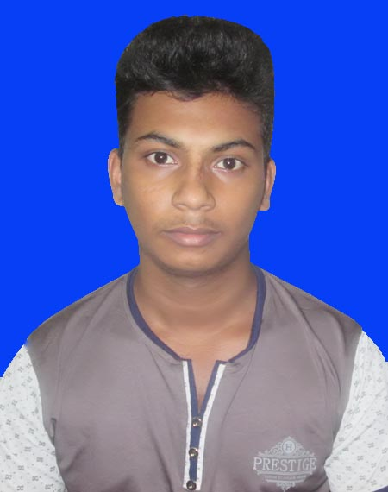

MD.ROKIBUL ISLAM
Address: Kazi Tower (3rd floor),Kuril bus stand ,Dhaka
Home Phone: 01957035799
Mobile : 01626418404
e-mail : nextapps.csl@gmail.com

Carrere Object:
I am reliable, well organized and used to working on my own initiative. I am able to prioritize my workload. I am comfortable working on my own or as part of a team.

Academic Qualification:

Exam Title | Institute | Result | Board | Pass. Year | Duration
J.S.C | Rajghat Jafarpur Secondary School | GPA: 3.13  out of 5 | Jessore | 2013 | -

Experience

Company Name : Csl Training
Designation : Office Manager
Duration : 1st February 2015-Till now
Responsibilities:
Office work maintain,windows,Computer servicing,welcome guest & other office work.
.
Computer Skill:

i) Microsoft Office Package.
ii) Internet Browsing & E-mail Operating
iii) English type.

Language proficiency:

Mother tongue | Bangla

Personal Information:

Name : Md.Rokibul Islam
Father’ Name : Md.Rafiqul Islam
Mother’s Name : Jarina Begum
Present address : Kazi Tower (3rd floor),Kuril Bus stand,,Dhaka.
Permanent address : Vill:Jognipasha, P.O: Rajghat
P.S: Fultala. Dist: Khulna.
Date of Birth : 6th April 2000
Gender : Male
Marital Status : Unmarried.
Religion : Islam (Sunni)
Nationality : Bangladeshi (By Birth)
Current location : Dhaka

Reference (s):

 |  | Reference
Name | : | Abdur Rahman
Organization | : | CSL Training
Designation | : | Co-ordinator
Address | : | Kazi Tower kuril bus stand,Dhaka-1212
Mobile | : | 01912429315
Relation | : | Brother

(Md.Rokibul Islam)

