MD. Abadur Rahman Rubel
Dishari 104/b Hawapara Sylhet , Bangladesh
rubelsust67@gmail.com
01727203010
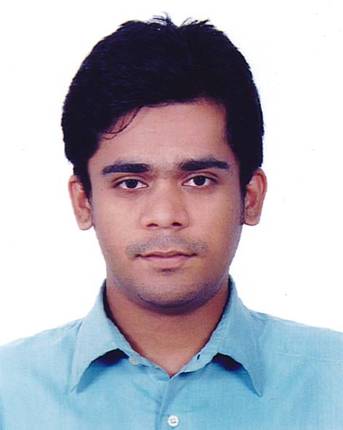

Education

Bachelor
B.Sc Hon's
Institution: Shahjalal University of Science and Technology
Subject/Major: Mathematics
Result: 2.65 out of 4.0
Year of pass/Academic Year: 2014

Diploma
Post graduation Diploma
Institution: IICT , Shahjalal University of Science and Technology
Subject/Major: Information Technology
Result: 3.26
Year of pass/Academic Year: 2017

HSC
HSC
Institution: MC College Sylhet
Subject/Major: science
Result: 4.6 out of 5
Year of pass/Academic Year: 2009

SSC
SSC
Institution: Sylhet Govt Pilot High School
Subject/Major: science
Result: 5.0 out of 5.0
Year of pass/Academic Year: 2007

Personal Details

Name: | : MD. Abadur Rahman Rubel
Email: | : rubelsust67@gmail.com
Father's Name | : Abdul Matin
Mother's Name | : Sujiya Khanom
Address | : Dishari 104/b Hawapara Sylhet , Bangladesh
Date of Birth | : 15 August, 1991
Mobile | : 01727203010
Alternate Mobile | : 01681480897
National ID | : 19919196216000067
Facebook ID | : https://www.facebook.com/Oodvut
Gender | : Male
Marital Status | : Unmarried

Achievement

*IELTS score: 6.5 ( L 6.5 ,R 6.5,W 6.0,S 6.5)
*GRE Score: 293 ( Quant 152 , Verbal 141 )
* General member of Mathematics society , Shahjalal University of Science & Technology 2012-2014
*Vice-president (organizing committee) , tourist club ,Shahjalal University of Science & Technology , 2011
*General member of RIM musical club 2010-2014

Reference

1. Hafiza Khatun Jabin
Popular Life Insurance LTD.
Underwriter
68 Hawapara , Sylhet Bangladesh
+8801732566577
2. Tanvir Ahmed
Shahjalal University of Science and Technology
Assistant Professor
Department of Physics
01736952151

