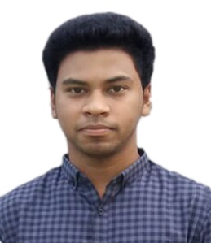
JABID HUSSAIN

Cell: +8801744817919
Email: j.h.rumon7@gmail.com

Career Objective
A responsible for the growth of career through optimal utilization of educational and Creativity. A desire to contribute effectively through motivation, discipline and hard work to reach the top level .I want to utilize my academic knowledge by working in a reputed company/institution/organization under any kind of situation.

NAME AND CONTACT INFORMATION:

NAME IN FULL : Jabid Hussain
Father's Name : Abdul Jalil
Mother's Name : Saleha Begum
Address (Present) : Vill : Amura , P/O : Amnia Bazar , P/S : Golapgong , Dist : Sylhet.
Address (Permanent) : Vill : Amura , P/O : Amnia Bazar , P/S : Golapgong , Dist : Sylhet.
Date of Birth : 12/05/1994
Telephone number : N/A
Mobile number : +8801744817919
Email address : j.h.rumon7@gmail.com

EDUCATION AND RELEVANT TRAINING:

Academic Qualification

1. Examination : Bachelor Degree (Pass)
Institute : Sylhet Government College
Department : B.A.(Pass)-01
Session : 2013-2014
Year of Passing : Running
Result : N/A
Authority : National University Bangladesh

2. Examination : Higher Secondary Certificate
College : Dhakadakshin Multilateral high school & college
Department : Humanities
Session : 2011-2012
Year of Passing : 2013
Result : GPA – 3.90 out of 05

3. Examination : Secondary School Certificate
College : Dr. Soyed Moqbul Hossain High School
Department : Humanities
Session : 2009-2010
Year of Passing : 2011
Result : GPA – 3.88 out of 05

Job Experience : N/A
Computer Skills
- MS Word

Language skills:

- Bangla (native)
- English (Medium)

INTEREST

- Travelling, especially to the indigenous places, places prone to nature
- Music
- Browsing Internet

REFERENCES:

Reference 01 Reference 02

Md. Rezaul Karim  Associate Learning Facilitator(ICT)  HR & Learning Division, BRAC  M: 01917699332  BRAC Learning centre, Sylhet  Sylhet, Bangladesh. | Najrul Islam  Lecturer English  Dr. Soyed Moqbul Hossain High School  M:01723311811  Amura, Golapgang, Sylhet  Bangladesh

Date…………………. …………………..................................... 07/12/2016 Jabid Hussain

