 | Nobarun 163/2, Sonarpara, Shibgonj, Sylhet
 | +8801788870801
 | runa.math18@gmail.com
Curriculum Vitae of RUNA BEGUM
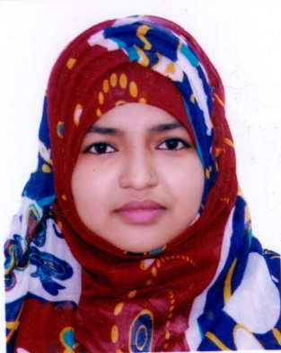

CAREER SUMMARY
Searching for a desirable opportunity with which I will have the scope in utilizing my skills and potentiality to do something innovative and from which I will be able to enhance my knowledge and efficiency.
PERSONAL QUALITIES
- Strong desires for leading an honest life with dignity.
- Aspiration to build a career showing superior performance.
- Energetic, sincere, hardworking, honest and dutiful.
COMPUTER SKILLS
- Microsoft Office Application (Word, Excel, PowerPoint).
- Computer Operating.
- Internet Browsing & Mail Checking.
LANGUAGE SKILLS
- Good communication abilities in Bengali & English both verbal and writing
EXPERIENCE
- S.P.P.M High School
Temporary Teacher (Mathematics)
August 2015 – December 2016
EDUCATIONAL QUALIFICATION
- Bachelor of Science (Hons.) 2017  Subject: Mathematics  Result: C.G.P.A- 3.66  M.C. College, Sylhet  National University  - Secondary School Certificate 2010  Result: G.P.A- 5.00  Group: Science  S.P.P.M High School  Board: Sylhet | - Higher Secondary Certificate 2012  Result: G.P.A- 4.60  Group: Science  Sylhet Govt. Women’s College  Board: Sylhet
INTEREST
Traveling, Cooking, Puzzles, Reading Books, Listening Music.
PERSONAL DETAILS
Father’s Name: | Abdul Gofur
Mother’s Name: | Gulbahar Begum
Parmanent Address: | Vill: Labour Para, P.O: Papermills,  P.S: Chhatak, Dist: Sunamganj.
Date of Birth: | 8th March, 1995
Religion: | Islam
Nationality: | Bangladeshi
Marital Status: | Unmarried
Declaration
I would appreciate if you give me an opportunity to work with you and to execute myself with your support. All the information provided here are correct and complete.

(Runa Begum)

