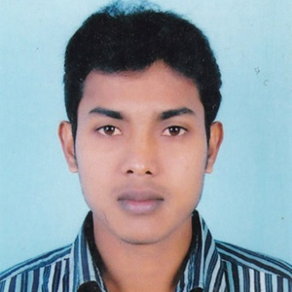
RESUME
OF

SAGIR AHMED
Contact No: +01727146046
sagirahmedsagor20@gmail.com

Career Objectives | To work in an environment where is an opportunity of self-assessment and improvement in both individual and group-based jobs that frequently faces with individual skills. I am self-motivated, intelligent and diligent and ready to go the extra leg to achieve the target.

Academic Qualification | - Bachelor of Art’s – ( Hon’s)  Institute Name : Govt.Ananda Mohan College,Mymensingh.  University Name : National University  Passing Year : 2017  Result : C.G.P.A-2.69 (Out of 4.00)  Subject : Philosophy.  - Higher Secondary School Certificate-(ALIM)  Institute Name : N. Akand Kamil Madrasah,Netrakona  Board : Madrasha  Group : Humanities  Passing Year : 2013  Result : GPA-3.25 (Out of 5.00)  - Secondary School Certificate-(Dhakil)  Institute Name : Anandapur Alim Madrasha.  Board : Madrasha  Group : Science  Passing Year : 2011  Result : GPA-4.31 (Out of 5.00)

Language Proficiency | Bengali : Mother tongue  English : Both in speaking and writing
Computer Knowledge | Basic Computer office application- Ms- Word, Ms- Excel, Ms- Access, Ms- Power Point, Data Base Management and Internet Browsing.(6 Months).

Personal Information | Name : Sagir Ahmed  Father’s Name : Abdul Latif  Mother’s Name : Jarina Akter  Date of Birth : 01-01-1995  Nationality : Bangladeshi  Religion : Islam  Sex : male  Marital Status : Married  Blood Group : A+

Permanent Address | Vill.- Dilura, P.O- Anandapur,  P.S.-Kalmakanda, Dist.- Netrokona.

Sincerely Yours

……………………
Sagir Ahmed

