Saima Akter Panna
E-mail : saimaakter99@yahoo.com
Phone : 01772291162
Address : House-3/4, Road-29, Block-D, Shahjalal Uposhahar, Sylhet, Sylhet Division 3100.

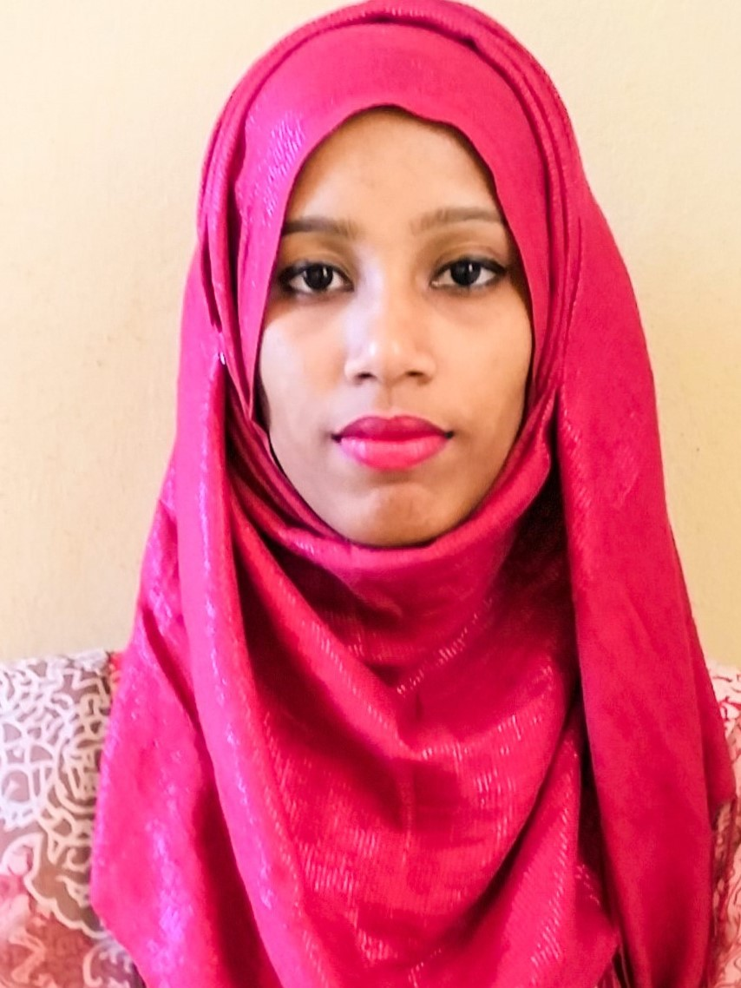

Objective
To succeed in an environment of growth and excellence and earn a job which provide me job satisfaction and self development and help me achieve personal as well as organizational goals.
Computer Skills
-Sound Knowledge of Ms-Word, Ms- Excel, Ms-Power Point & Good Typewriting speed.
-Well experienced with use of internet.
Language Proficiency
Excellent communication skills in English and Bangla both written and oral.
Work experience
Internship | 1st Feb,2016 - 30th March, 2016
Jalalabad Gas Transmission Distribution System Limited
During BBA(Honors) have two-months research experience on " Financial System of Jalalabad Gas Transmission Distribution System Limited" .
Education
Bachelor of Business Administration (BBA)
Institute | Shahporan Institute Of Business & Technology
Major | Finance
Board | National University
Passing Year | Examination Year 2014 (held in 2016)
CGPA | 2.53 (out of 4.00 )
Higher Secondary Certificate (HSC)
College |  | Jalalabad College
Board |  | Sylhet
Group |  | Business Studies
Passing Year |  | 2010
GPA |  | 3.90 (out 5.00)

Secondary School Certificate (SSC)
School | Shahjalal Uposhahar High School
Board | Sylhet
Group | Humanities
Passing Year | 2008
GPA | 3.31 (out of 5.00 )
Interests
Reading, Traveling, Swimming, Watching Movies, Enjoying Music & Sports.
Personal Profile
Father's Name | Abdul Haque
Mather's Name | Husne Ara Begum
Date of Birth | 25-12-1991
Gender | Female
Marital Status | Unmarried
Nationality | Bangladeshi
Religion | Islam (Sunni)
Permanent Address | Village-MadhabPur , P/O - Kamal Bazar , P/S- Bishawnath , Sylhet

References
1. Professor Md Wadud Islam
Lecturer
Dept. of Accounting
Madan Mohon College, Sylhet.
Contact No: 01717-457520
2. Pronab Saha
Sr.Lecturer
Dept. of BBA
Sylhet International University, Sylhet
Contact No: 01741-108353

I do hereby declare that the above given statements are true & correct to the best of my knowledge.

Yours Truly

..........................................
(Saima Akter Panna)

