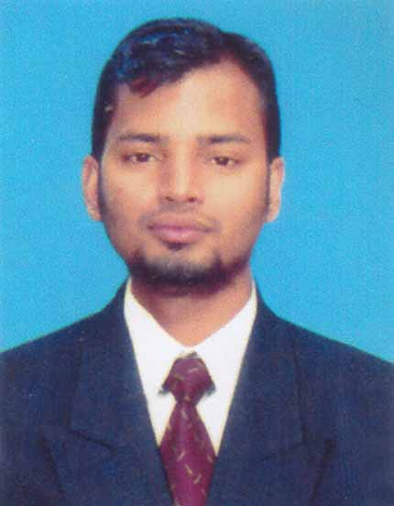
CURRICULUM VITAE
OF
SANJOY DEY

Mailing address
Guru Das Mohajan Bari, Word: 06, Vill: Noajishpur,
P.O: Natunhat, P.S: Raozan , Dist: Chattogram
Mobile: 01819934602
E-mail:deysanjay216@gmail.com

Career Objective
I am seeking for an opportunity to serve in company where I can use my talent and skill to expand the company. I like to take challenges for the benefit and growth of the organization with my skill and activities. Through hard works, dedication and strong determination I want to build my carrier as well as contribute for the success of industry so that the company may achieve its goals.
Academic Qualification
Masters of Arts (M.A)
Institution : University of Chittagong
Subject : Sanskrit
CGPA : 3.08 (out of 4.00)
Session : 2016-2017
Passing Year : 2017

Bachelor of Arts (B.A)
Institution : University of Chittagong
Subject : Sanskrit
CGPA : 3.26 (out of 4.00)
Session : 2012-2013
Passing Year : 2016

Higher Secondary Certificate (HSC)
Institution : Hazi Badsha Mabea College
Group : Business Studies
Board : Chittagong
Result : 2.90 (Out of 5.00)
Passing Year : 2012

Secondary School Certificate (SSC)
Institution : Fatehnagar Noajishpur Woadudia High School
Board : Chittagong
Group : Business Studies
Result : 3.63 (Out of 5.00)
Passing Year : 2008

Language Proficiency
Mother tongue: Bengali
Second Language: English, Sanskrit - Fluent in reading, writing, listening and speaking.

Extra Curriculum
Office Application, Internet & E-mail.
Self Motor Driving

Personal Details
Name : Sanjoy Dey
Father’s name : Jadu Dey
Mothers name : Sabita Dey
Permanent Address : Guru Das Mohajan Bari,
Word: 06, Vill: Noajishpur,
P.O: Natunhat, P.S: Raozan , Dist: Chattogram
Date of birth : 01-11-1991
Marital Status : Unmarried
Religion : Hinduism
Nationality : Bangladeshi.

Declaration of Authenticity
I do hereby declare that all information here is true to my knowledge. If required and where applicable, this document can be supported by appropriate authentic certificates/papers.

Reference
Rajpati Das  Assistant Professor  Department of Sanskrit  University of Chittagong  Cell: 01815500053 | Tarun Kanti Dev  Assistant Director  Bangladesh Bank  New Market Branch, Chittagong.  Cell: 01815865056

____________________
Date: Signature

