
CURRICULUM VITAE
Of
SARWAR HOSSAIN NADIM

House No. 5, Block-B, Nowapara, Akhalia, Sylhet.
Mobile: +88 01794085614
E-mail: nadimsarwar217@gmail.com

OBJECTIVE
To upgrade myself as an efficient, honest & diligent person in a wonderful environment from where I will get guideline to build a challenging career. My promise, drive & attitude deserve sophisticated job in an organization, which can guide me face challenges of the new millennium.

EDUCATION QUALIFICATION

Name of Exam : Secondary Certificate (SSC)

Institute : Border Guard Public School & College
Result : GPA- 4.00
Group : Business Studies
Board : Sylhet
Year of Passing : 2012

Name of Exam : Higher Secondary Certificate (HSC)

Institute : Blue Bird School & College
Result : GPA- 4.40
Group : Business Studies
Board : Sylhet
Year of Passing : 2014

Name of Exam : LLB (Hon’s)

Institute : Metropolitan University, Sylhet.
Result : 2.50

SPECIALITY
- Punctual and committed to work.
- Responsible and disciplined.
- Feel comfort to work with group.

SELF ASSESSMENT
- Willing to learn and build-up career by accepting responsibilities on all aspects.
- Energetic, Sincere, Hard Working and Dutiful.
- Able to set prioritize and routine tasks.
- Able to work at any time any place.

COMPUTER PROFICIENCY
Office Program : MS Word, MS Excel, MS Powerpoint & Internet Browsing.

SKILLS
- Good at English, Accounting.

EXPERIENCE
- Former Teacher at Protiva Coaching Home (1 Year).
- Worked at Swapnil Sari Ghar (03 Months).
- Former Manager at The Sahebian’s Restaurant (6 Months).

SPORTS
- Two Times Champion in M League (Football).

PERSONAL PROFILE
Name : Sarwar Hossain Nadim
Father’s Name : Md. Sharfuddin Miah
Mother’s Name : Mst. Monwara Begum
Permanent Address : House No. 5, Block-B, Noapara, Akhalia, Sylhet.
Date of Birth : 12 October 1995
Religion : Islam
Marital Status : Unmarried
Sex : Male
Nationality : Bangladeshi
NID No : 820 147 9717

I hereby declare myself that all the statement in this C.V. is authentic complete and correct of the best of my knowledge and belief.

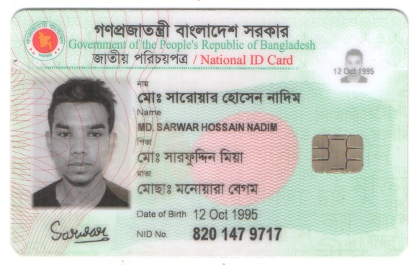

Sarwar Hossain Nadim
Signature & Date

