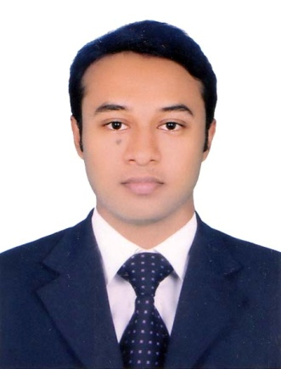
Md.Shakil Ahmmed
Address:G-P-CHA-125, Mohakhali,Dhaka-1212, Bangladesh.
Cell: +8801938380792
E-mail: shakilsajol@gmail.com

Career Objectives:
To obtain an entry-level position in a professional environment and have the opportunity for personal development.

Academic Qualification:
Degree/ Examination | Discipline/ Subjects | Institution / University | Result | Passing Year
B.Sc. in EEE | Electrical | Northern University Bangladesh | 3.622 (out of 4) | 2018
H.S.C | Science | Joypurhat Govt. College | 4.30 | 2013
S.S.C | Science | Mohipur Maulana Bhasani High School | 4.94 | 2011

Internship:
Industrial Training at Bangladesh Power Development Board (BPDB).

Language and Professional Skills:
Language Skills: Proficiency at understanding, speaking, reading and writing Bengali & English.
Computer Skills:MS office programs: MS Word, MS Power Point and MS Excel, Internet Browsing, E-mailing and satisfactory typing speed.
Operating Skills: Windows 7, 8, 10.

Additional Qualification:
- Strong written and verbal communication ability in both Bengali and English.
- Highly motivated and eager to learn new things.
- Positive thinking and hard working.
- Ability to work under pressure and to work individual as well as team.
- Passionate about work.
Interests:
Photography, travelling, observing & helping people etc.
Personal Details:
- Father’s name : Md. Sanowar Hossain
- Mother’s name : Shahida Bagum
- Present address : G-P-CHA-125, Mohakhali, Dhaka-1212
- Permanent address : Village:Bazitpur, Thana: Panchbibi, District:Joypurhat
- Date of birth : 7th August,1994
- Sex : Male
- Blood group : O+ (Positive)
- Marital status : Single
- Religion : Islam
- Nationality : Bangladeshi (By Birth)
- National ID NO : 462 657 7458
- Contact No. : +8801938380792
- E-mail : shakilsajol@gmail.com
References:

1. Md Badiuzzaman
Associate Professor
Dept. of EEE, Northern University Bangladesh.
Mobile: +8801751664688
E-mail: badiuzzaman2000@yahoo.com

2. Utsho A Arefin
Assistant Professor
Dept. of EEE, Northern University Bangladesh.
Mobile: +8801534550248
E-mail: arefin@nub.ac.bd

I declare that all the information presented here are true to my knowledge. If required and where applicable, these documents can be supported by appropriate authentic certificate.
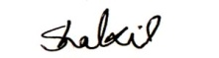

Md.Shakil Ahmmed

