Personal Resume
Of
Md. Sheikh Mujibur Rahman

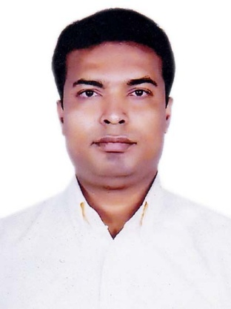

Mailing Address
986, Rasheda Mansion, Middle Rampur,
Bow Bazar, Amtola, P.O: Rampur- 4224,
P.S: Halishahar, Dist : Chattagram.
Contact : +88 01714-282990
- E-mail : sheikhmujiburrahman88@gmail.com

Resume
Of
Md. Sheikh Mujibur Rahman

Career
Objectives
 | To acquire a challenging position in a reputed organization where I could use my hard working and creative skills which would enable me as a fresh graduate to grow while fulfilling organization goals.
Career
Summary
- Have working experience as “Sr. Asst. Executive” of “Regensea Lines Ltd.” General agent of Hanjin Shipping Company, Which in situated in Ispahani Building 2nd Floor, Agrabad C/A, Chittagong, Bangladesh from 11th November, 1998 to 19th October, 2011.

Responsibilities to Regensea Lines Ltd.
- Data entry of Vessel wise expenditure.
- Data entry of Cash vouchers (Debit/Credit).
- Data entry of Journal Vouchers (Debit/Credit )
- Date entry of Pay Roll.
- Preparation of Car Statement.
- Reporting and corresponding to Departmental Head and Auditor as and when required.

- Have experience as Medical Promotion Officer (MPO) of “White Horse Pharmaceuticals” since 6th December, 2011 to December 31, 2013 after completion a successive training period from 19th November, 2011 to 3rd December, 2011 under the management of the company.
Academic Attainment
Bachelor of Arts  (B.A) | Institution  Years of Passing  Subject  Result  University | :  :  :  :  : | Rangunia College  1993  Humanities  3rd Class  National University
Higher Secondary Certificate (H.S.C) | Institution  Years of Passing  Group  Result  Board | :  :  :  :  : | Rangunia College  1991  Humanities  3rd Division  Comilla
Secondary School Certificate  (S.S.C) | Institution  Years of Passing  Group  Result  Board | :  :  :  :  : | P.D.B High School  1988  Science  3rd Division  Comilla
Skills

Computer Training Program | Operating systems of Accpec, Windows 98/XP, MS Dos. MS Word, MS Excel, Database-Foxpro, Microsoft Access, Internet Browsing and etc.
Language | Proficient at speaking, reading and writing in  Benglai and English.
Personal
Details

 | Name | : | Md. Sheikh Mujibur Rahman
 | Father’s Name | : | Late Md. Nurul Huda
 | Mother’s Name | : | Late Rasheda Begum
 | Date of Birth | : | 15th June, 1973
 | Marital Status | : | Married
 | Gender | : | Male
 | Nationality | : | Bangladeshi by birth
 | Religion | : | Islam
 | Interest | : | Reading Book & Traveling.
Permanent
Address

986, Rasheda Mansion, Middle Rampur,
Bow Bazar, Amtola, P.O: Rampur- 4224,
P.S: Halishahar, Dist : Chattagram.
Declaration of Authenticity

 | I am Md. Sheikh Mujibur Rahman, the undersigned, declare that the information presented in this document is authentic to the fullest of my knowledge and describe my qualifications.
Reference

Mr. A.S.M Nayeem, FCA
Advisor of Karnaphuli Group
HR Bhaban (3rd Floor)
Kakrail, Dhaka.
Mobile : 01819-310936
Mr. Mushfiqur Rahman, ACA
Qualified Assistant
Aziz, Halim, Khair Chowdhury & Co .
Chartered Accountants
Baitul Mesbah, House # 79, Road # 12-A,
Dhanmondi , Dhaka.
Mobile : 01819-547366

(Md. Sheikh Mujibur Rahman)

