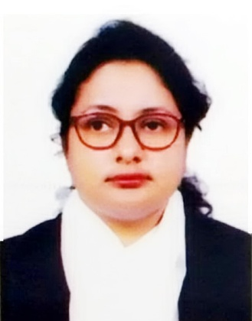
Curriculum Vitae
Of
Sheuli Dey
Cell : +88018 30 199 952
Address: Vill : Ghona para,
P.O / P.S : Cox’s Bazar Sadar,
Dist : Cox’s Bazar-4700.

Career Objective:

In line with my continued interest and performance in this stage I have decided to build up my career in the professional field. So as a professional worker, I would like to show my immense aspiration to prove myself as a sincere and energetic person through extensive hard working and integrity.

Experiences :
- I am Working with TDH(Terre des home) as a Child protection (Case Worker) from 25-08-2019 & Now.
- I have Worked at BRAC as a SGBV ( Case Worker) from 15-10-2018 to 22-08-2019.
- I have Worked at Care Bangladesh as a Field Volunteer For 2 Years.
- I have Worked at Cox’s Bazar Sadar Hospital as a Altra Sonographer for 2 years.
- I have worked at Cox’s Bazar Upzilla Health Complex as FPAB for 1 Years.

Academic Qualification:

Master of Laws (LL.M)  Institute :  Subject :  Result :  Passing Year : | Northern University Bangladesh  Law  CGPA- 2.689  2018
Bachelor of Law (LL.B)  Institute :  Subject :  Result :  Passing Year : | Cox’s Bazar International University  Law  CGPA- 2.75  2017
Higher Secondary Certificate ( H.S.C)  Passing Year :  Result :  Group :  Institution :  Board/University : | 2013  GPA-3.77  Secretarial Science  Cox’s Bazar City College  Chittagong Board.
Secondary School Certificate ( S.S.C)  Passing Year :  Result:  Group :  Institution :  Board/University : | 2011  GPA-3.06  Business Studies  Moheshkhali Model High School  Chittagong Board.

Language Proficiency:

Language Read Write Speak
Bengali Fluent Fluent Fluent
English High High High
Other Qualification:

- Organizing Program & Motivating For Work and Leading Them There Duties Properly.
- Good interpersonal communication skill.
- Ambitious courteous, amicable, energetic, enthusiastic, creative, confident, punctual.
- Ability to any environment.

Computer Skills :

Have a good knowledge in Office Management:
- Microsoft Office XP (MS Word, MS Excel, MS PowerPoint)
- Internet Browsing (Web Browsing, Send / Receiving E-Mail)
Personal Information:

Full Name : Sheuli Dey
Father's Name : Anil Chandra Dey
Mother's Name : Shefali Rani Dey
Date of Birth : 23rd December, 1993
Religion : Hindu
Blood Group : O+ (Positive)
Sex : Female
Marital Status : Single
Nationality : Bangladeshi
National ID Card No. : 19932214947000394
Permanent Address
Village : Puichara
Post Office : Hoanak - 4710
Police Station : Moheshkhali
District : Coxs’ Bazar

Declaration:

I do hereby declare and certify that all information stated above in this resume is true and complete to the best of my knowledge

______________________________________________________________
(Applicant's Signature)

