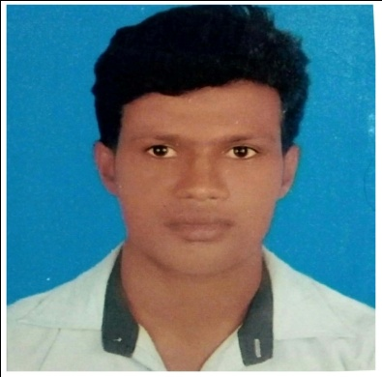
CURRICULAM VITAE
of
MEHEDI HASAN

Mobile: 01637193221
Email: mastermehedi1996@gmail.com

CAREER OBJECTS | To serve the nation and to be a member of an organization where I can update my knowledge and skills under a competitive and challenging environment to prepare myself for future career.
STRENGTH | - Able to make any challenging duties under pressure.  - Have a sound strength into concluding field survey, making report and present those in front of the audience in English with a defensive way.  - Have sound strength in presiding over any meeting.
EDUCATIONAL BACKGROUD | Degree Pass |  | Institution: Noapara Collage,Jessore.  Board: Dhaka  Group: B.S.S  Passing Year: 2017  Result: 2.92
EDUCATIONAL BACKGROUD | HSC |  | Institution: Noapara Collage ,Jessore.  Board: Dhaka  Group: Business Management.  Passing Year: 2014  Result: 4.46
EDUCATIONAL BACKGROUD | SSC |  | Institution: Noapara Shonkor Pasha High School,Jessore.  Board: Dhaka  Group: General Mechanics  Passing Year: 2012  Result: 4.69
LANGUAGE PROFICIENCY |  | Reading | Writing | Speaking
LANGUAGE PROFICIENCY | Bangla | Excellent | Excellent | Fluent
LANGUAGE PROFICIENCY | English | Excellent | Moderate | Moderate
JOB EXPERIENCE | - AKIJ JUTES MILLS LTD Noapara,Abhynagar,Jessore. (About 1 year Experience as an Oparator)  - ACS TOWEL LTD Tatlabo,Rupgonje,Narangonje. (About 1 year Experience as an Oparator)  - SAF INDUSTRISE LTD Noapara,Abhynagar,Jessore. (About Runing experience as Storekeepar )

Name | : Md.Mehedi Hassan( Shohel)
Fathers Name | : A.B.M.Ayub Hossain
Mothers Name | : Mst.Shahida Begum
Permanent Address | : 605/2,Akterpur,Taltala,Abhaynagar,Jessor
Present Address | : 605/2,Akterpur,Taltala,Abhaynagar,Jessor
Date of Birth | : 18/09/1996
Nationality | : Bangladeshi(By Birth)
Religion | : Islam
Sex | : Male
Marital Status | : Unmarried
Blood group | : A+
Height | : 5 Feet 6 Inch
Mobile Number | : 01637193221
Email Address | Mastermehedi1996@gmail.com

Md.Mehedi Hassan( Shohel)
Date:

