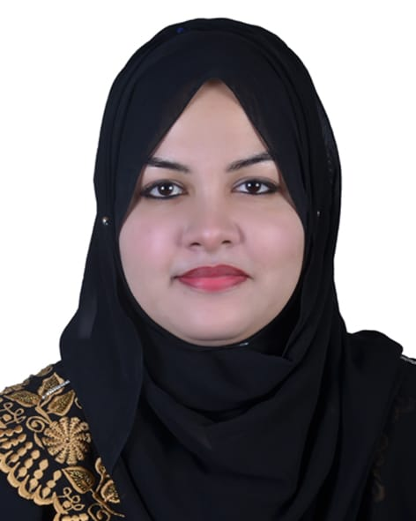
Curriculum Vitae of
Syeda Nazifa Salsabil
Mailing Address:
Fazilchist, Sylhet
Contact : +88 01775146952
Email :nazifa46130@gmail.com
CAREER OBJECTIVES:
Achieving a dynamic and challenging job where I could use my educational, professional and interpersonal skills that will add desired value to your organization and develop my career with the best effort.
JOB EXPERIENCE:
- I am working as a Call Center Executive at Creative Bee, Sylhet since ( 3rd May 2019 to continue).
- I worked as an Senior admission officer at AHZ Associates, Sylhet ( 3rd February to 30th July, 2018)
- I worked as a Virtual Assistant (Project) in Staff India, Sylhet (2nd April to 28th September, 2017)
- I worked as a Sales Executive (Cash) in Shohani Sharees, Anarkoli shopping center (From July 2015 to September 2016)
- I worked as an article writer of Bangladesh Institute of Professional Studies (2015 to 2017)
- I have completed internship course of three months in Agrani Bank, Shantinagor Branch, Dhaka(July to October 2016)
- 5.I worked as a Teacher in various School & Coaching center, Dhaka(From 2012 to 2015)
EDUCATIONAL QUALIFICATION:
Masters of Business Administration (MBA)
Institute : Leading University, Sylhet
Subject : Marketing
Passing Year : 2018
Result : GPA-3.42

Bachelor of Business Administration (BBA)
Institute : University of Information Technology & Sciences (UITS),Dhaka
Subject : Finance
Passing Year : 2016
Result : GPA-3.53
Higher Secondary Certificate
Institute : Siddheswari Girls College
Board : Dhaka
Group : Commerce
Passing Year : 2011
Result : GPA- 4.50
Secondary School Certificate ( S.S.C) :
Institute : Rajarbagh Police Line High School
Board : Dhaka
Group : Commerce
Passing Year : 2009
Result : GPA- 4.56

COMPUTER LITERACY:
Good command on following application:
- Microsoft Word
- Microsoft Excel
- Microsoft Power Point
- Internet Browsing
- E-mail

LANGUAGE PROFICIENCY:
- English: Can speak, read, write and understand.
- Bengali: Can speak, read, write and understand.

STRENGTH:
- Ability to work under pressure efficiently and independently with good self presentation.
- Ability to create excellent interpersonal relationship and good team work.
- Ability to drive motorcycle.

ACHIEVEMENT:
Scholarship: SSC from HSBC Bank, Dhaka
BBA from UITS University, Dhaka

INTEREST AND HOBBIES:
- Traveling new places.
- Watching movies.
- Net browsing.

PERSONAL DETAILS:
- Name : Syeda Nazifa Salsabil
- Father’s Name : Syed Moshahid Ali Shah
- Mother’s Name : Syeda Kamrun Nahar
- Present Address : Fazilchist, Sylhet.
- Permanent Address : Vill: Khadimpara, P.O: Baramchal,
P.S: Kulaura, Dist: Moulvibazar. Division : Sylhet.
- Religion : Islam (Sunni)
- Nationality : Bangladeshi

 |  | Reference: 01 | Reference: 02
Name | : | Dr Wahiduzzaman Khan | MD Masudul Haque
Organization | : | Leading University .
Designation | : | Associate Professor & Head (Acting), Hotel Management, Leading University, Sylhet. Phone: | System Analyst  Secretariat ,Motijheel,Dhaka
Mobile | : | 01939-993399 | Phone-01915026423
E-Mail | : | wzk_roence@yahoo. co.uk
Relation | : | Academic | Professional

DECLARATION:
I, the undersigned, certify that to the best of my knowledge and belief, these curriculum vitae correctly described.

Nazifa
.......................................
(Syeda Nazifa Salsabil)

Date: 7-12-2019

