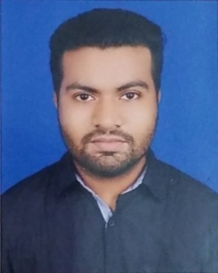
S.M. SABBIR RAHAMMAN
House # 1 NO WASA, Road # 27
New D.O.H.S. Mohakhali, Dhaka.
Mobile: 01671865491, 01726722812
Email: smsabbirrahaman69@gmail.com

Career Objective

To work for an organization that encourages a fully professional working environment and greater opportunity for career development.

Can Offer the Employer
Well-organized and proficient with details.
Enthusiastic, self-motivated & dynamic in handling complex situations.
Able to work under pressure and to make well-reasoned and timely decisions.
Persistent and dedicated in accomplishing tasks and meeting deadlines.
Excellent interpersonal and team skills.

Educational Information

2016- Bachelor of Science (B.Sc.) in Civil Engineering (Continuing)
Fareast international university (FIU)

2009-2014 Diploma in Civil Engineering
CGPA - 3.16 out of 4.00
Rajdhani Polytechnic and Textile College - RPTC

2009 Higher Secondary Certificate (H.S.C.) in Business
GPA: 3.00 out of 5.00
Tejgaon College Dhaka, Bangladesh

2007 Secondary School Certificates (S.S.C) in Business
GPA: 3.25 out of 5.00
I.P.H High School

Work Experience

- 4 years 3 months experience Directions.
Position: Chief Assistant Director (Clapstick Films), (22/09/2011 – 30/10/2015)
- 1 years 5 months experience as a site engineer, TAQWA HOLDINGS LIMITED (03/01/2016 , 31/07/2017)

Current Position

Working as a site engineer FALCON HOMES LIMITED (10/12/2017 – Till now)

Job Responsibility

Understood the various steps undertaken before construction.
Calculating requirements to plan and design the specifications of the civil work required.
Ensured safety by monitoring the site.
Assisting seniors in forecasting the cost quantity and budget of equipment, manpower and labour.
Calculating the construction area

Internship
Company: Sena Kalyan Sangstha
Duration: 6 months
Project on: Residential building

Language Proficiency
Efficiency in both Bengali and English speaking and writing.
Interest and Hobby

Listening Music
Playing Football and Cricket

Personal Information
Father’s Name : S.M. Ayub Ali
Mother’s Name : Asia Begum
Date of Birth :10th March, 1991
Nationality : Bangladeshi
Religion : Islam
Marital Status : Single

_____________________
S.M. Sabbir Rahamman

