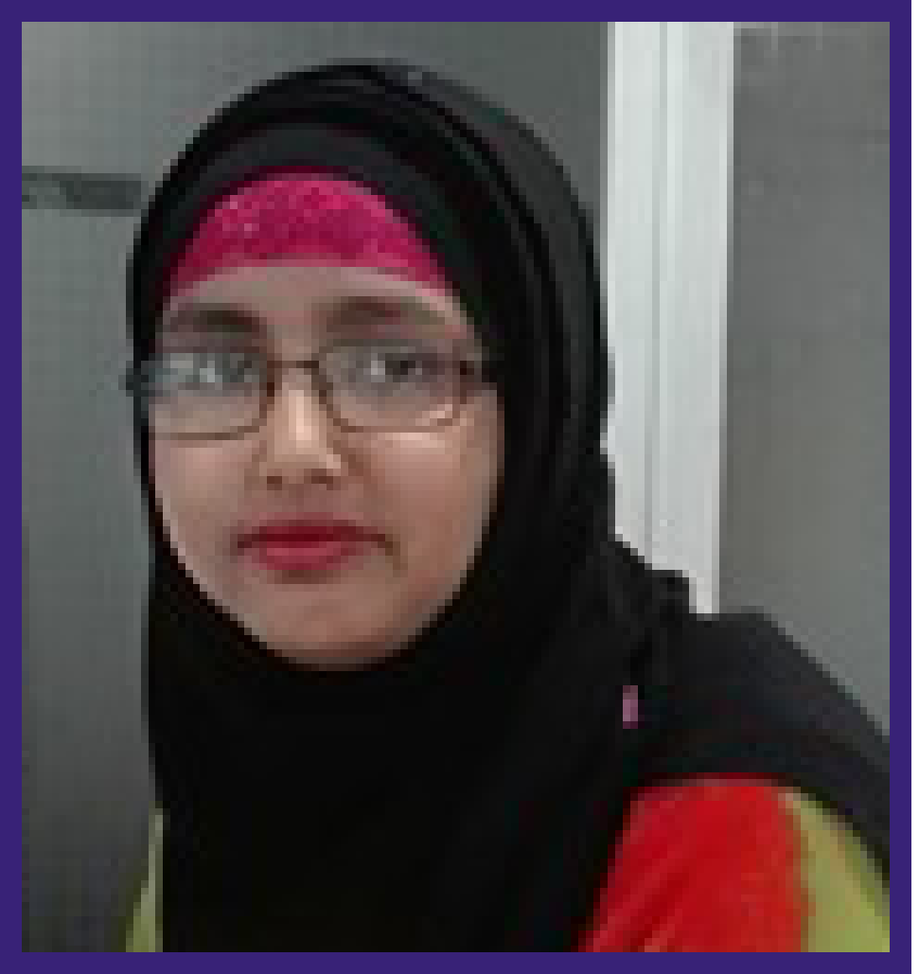  - Sajna Akther, Lawai, South Surma, Sylhet- 3100.  - Bangladesh  - +880 - 1750884174  - +880 - 1717092738  - shejuthysaaj@gmail.com  SKILLS  PERSONAL  Personal Information  Father : Late Iskandar Ali  Mother : Hawarunnessa  Date of Birth : 21 July 1991  Nationality : Bangladeshi  Religion : Islam  Sex : Female  Marital Status : Single  Blood Group : AB (₊) Positive  Reference  Satya Ranjan Sarkar  Director  Nywta Computer training Academy,  Contact No. 01818651912  Shajuddinmd abul Khaer Saju  Instructor of Electronics Department  Sylhet Polytechnic Institute, Sylhet.  Contact No. 01712593653 | Sajna Akther  EDUCATION  ◊ Diploma in Engineering  Year of Progress : 2013  Result : CGPA 3.37 (out of4)  Institution : Sylhet Polytechnic Institute, Sylhet  Awarding Body : Bangladesh Technical Education board.  ◊ Secondary School Certificate  Year of Passing : 2008  Result : GPA 3.81  Institution : South Surma High School, Sylhet.  Group : Humanities  EXPERIENCE  Chalo Technology Ltd.  Position: Business Executive  Duration: 01 July 2018 to 01 Dec 2018.  Academy of International Management Studies (AIMS)  Position: IT Instructor  Duration: 01 February, 2017 to 30 June, 2018.  Daily Provat vela ( Surma Tour, Surma Market, Sylhet )  Position: Office Assistant  Duration: March 01, 2017 – 01, Febuary 2017.  Nywta Computer Training Academy (East Darga Gate, Amborkhana, Sylhet)  Position: Office Assistant  Duration: May 05, 2014 – 31, December 2016.  Other Qualification  - Diploma in Computer Science  Year of Passing : 2013  Awarding Body : Bangladesh Technical Education Board  - Diploma in Graphics Design ( Six Months):  Awarding Body : Bangladesh Technical Education Board  IDEAl Training Center, Sylhet  - Internship:  Industrial Training of Basic Electronics (Three Months)01 October, 2012 to 01 January 2013.  Self Appraisal  - The ability to work under pressure and meet targets  - Organizing and leadership competence.  - Able to analyze and interpret complex information.  - Helpful and innovative willingness to work in team.  - Able to deal with highly confidential matters professionally & discreetly.  - Ability to interact with subordinate work force.  - Can learn quickly the necessary details of work.  - Be patient, tactful, diplomatic and approachable.
  MS Office
  Photoshop
  Internet
  Network
  COMMUNICATION
  ORGANIZATION
  TEAM PLAYER
  CREATIVITY
  SOCIAL

I do hereby declare that all above information is true and correct to the best of my knowledge. I authorize the respective authority to verify the information provided in this resume.

Sincerely,
Sajna Akther

