MD. SABBIR HOSEN 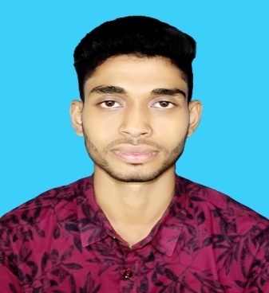
Address: Zirani Bazar, B.K.S.P, Ashulia, Savar, Dhaka 1349
Phone: +8801754500410
E-mail: mssabbir2010@gmail.com

CAREER OBJECTIVE
To make the best use of my skills and knowledge so that I would be able to sustain in any situation where I can also enjoy the challenging work environment and also can maintain a long term relationship with the organization.

Academic Qualification

2019 :– Present: Diploma Textile Engineering
Image Institutes of Textile Engineering Rangpur Bangladesh
Textile Engineering (CGPA: 3.59) on sale of
4.00.

2015 Dahkil Examination
Char Sazai Dakhil Madrasa.
Humanities, GPA: 4.38 on scale of 5.00.

Extra-curricular activities
- Internships Turag Garments & Hosiery Mills Ltd.
- Participate in school sports &extra other curriculum also.
- Participate in different case study and poster competition.
- Submitted research report on “Traditional shopping vs Online shopping”

Computer Skills
- MS office( Word, Excel)
- Power point

Language Proficiency
Proficiency in understanding English and Bengali reading, writing, listening & speaking.
Self-Assessment
- Have efficiency in writing and understanding business letters and proposals.
- Strong verbal communication skills as demonstrated when delivering presentations at University. Audiences ranged from 40 to 50 people.
- Sincere, hardworking & dutiful toward the work.

Personal Information
Name : Md, Sabbir Hosen Father Name : Md. Mahabur Rahman
Mother Name : Most. Shirina Khatun Date of Birth : 22/04/1998 Permanent Address : Char Sazai, Kodalkati, Rajibpur, kurigram. Nationality : Bangladeshi Religion : Islam. Marital Status : Unmarried Interests : Travelling, helping people, working with new things & Music.

References
Md. Azizur Rahman  Head of the Department of Textile Engineering  Image Institutes of Textile Engineering Rangpur Bangladesh  Mobil : +8801768531447  E-mail : | Md. Mizanur Rahman  Senior HR & Admin Officer  A-One (BD) Ltd.  DEPZ Gonakbari, Ashulia, Savar, Dhaka.  Mobil : +8801731445615  E-mail :

Date: ……………………..….Signature:.....................................

