PERSONAL INFORMATION | MD. SHABER AHMED
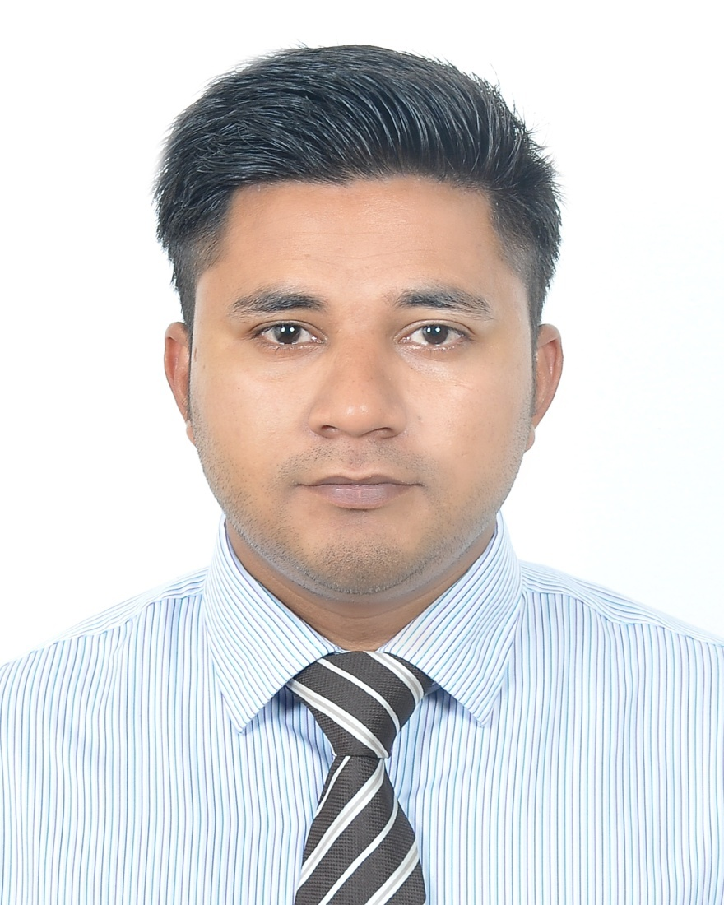
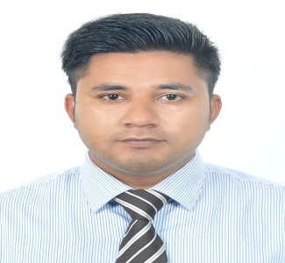 | 3/D, 34 Nirjor , Lovely Road, Subidbazar , Sylhet
 | +881711429326 , +8801721227137
 | ahmed.shaber7@gmail.com
 | Sex: Male| Date of birth 11/12/1992 | NationalityBangladeshi
personal statement | To use my sales and marketing oriented skills in the best possible way for  achieving the company’s goals .
WORK EXPERIENCE
The City Bank Limited.
Sales Officer
February 14,2017 to December 06 ,2018
- Achieve target on daily, weekly & monthly basis set by respective Sales Team Manager.
- Collect & complete applications with required documents on daily basis from good & prospective clients.
- Prepare call report on daily, weekly & monthly basis and submit to Sales Team Manager regularly.
- Ensure proper filling up of application forms by clients& make sure about the signature.
- Ensure collection of all documents and concerned regarding the authentication of those documents.
- Ensure proper service provided to each customers as par bank policy.
ACADEMIC QUALIFICATION

Spring 2017 | Master of Business Administration
Spring 2017 | Concentration: Marketing
Spring 2017 | CGPA: 3.50 out of 4.00  Leading University, Sylhet
Fall 2015 | Bachelor of Business Administration
Fall 2015 | Concentration: Marketing
Fall 2015 | CGPA: 2.84 out of 4.00  Leading University, Sylhet
2011 | Higher Secondary School Certificate
2011 | Concentration: Business Studies
2011 | CGPA: 4.70 out of 5.00  Sylhet Commerce College, Sylhet
2009 | Secondary School Certificate
2009 | Concentration: Humanities  CGPA: 3.75 out of 5.00  Bhadeshwar Nasir Uddin High School , East Bhadeshwar

ADDITIONAL INFORMATION

Personal Information | Mother's Name: Ayesha Begum.  Father's Name : Nurul Islam  - National ID Number : National ID Number : 3290699234  - Permanent Address : Poschimbag , South bhadeshwar , Bhadeshwar , Gulapgonj Sylhet .
Extra Curricular Activities | - President , Leading University Social Services Club (2015-2016)  - Teacher at ALO School - A voluntary educational program ( September 2012-May 2015)  - Coordinator -ALO School (2014-15)- A voluntary educational program  - Senior Executive Member, Orpheus(A musical club of Leading University)

References | Professional  Mohammad Humayun Kabir  Cluster Head of Branch ,Group 6  The City Bank LTD  Address: Metro Center (1st Floor), South Dhopadhighir Paar, Bondor Bazar East, Sylhet - 3100  Cell: 01714403130 | Professional  MD Rezaur Rahman  SAVP & Branch Manager  The City Bank LTD  Address: Amberkhana Branch B-100,East Darga Gate Airport Road, Sylhet  Cell: 01711-036000
I declare that to my knowledge the information above is correct & complete. Would you please call me to serve with you, then I will show my efficiency.
Thank you.

MD SHABER AHMED

