Md.SadikurRahman  Address:Sorufoud,Darbost,Jaintapur  Sylhet-3100.  Contact No: +88-01715744452; +88-01400176979  E-mail: sadik744452@gmail.com | 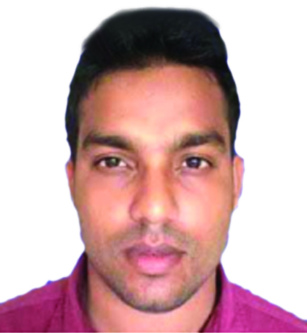
CAREER OBJECTIVE

To undertake a challenging career that offers development opportunity and provides wide range of congenial arena. Performing a creative and exciting job where talent, conceptual ability, leadership, communication and innovative capabilities can be efficiently utilized.

EDUCATIONAL BACKGROUND


Diploma in-Engineering Technology
Institute : Brahmmonbariapolytechnic institute.
CGPA : 3.25 out of(4.00 )
Group : Architecture & interior design.
Board : Bangladesh Technical Education Board (BTEB).
Year of passing : 2014.
Major Courses: Structural mechanics, Theory of structure, Design of structure, estimating costing, Sarveying1&2, Interiordesign1&2&3, Construction process1&2, Detail Drawing, Graphics,Cad&Digital visualization.


Secondary School Certificate (SSC)
School : BrigrediarMojumdarbiddyanicaton,jaintapur,Sylhet.
CGPA : 4.55out of 5.00
Group : Electrical.
Board : Bangladesh Technical Education Board (BTEB).
Year of passing : 2010.

Industrial Attachment
- Diploma in engineering: Tamannainteriors,Puranapaltan,Dhaka.
PROFESSIONAL TRAINING

- I have Completed Institution of Diploma Engineers Bangladesh(IDEB)Membership,CertificateMembership No:47376.
- Freelancer Training: Jaika ,Gwainghat,Sylhet.
- Trade CourseTraining: Steel binding & fabrication.
Seip-Rhab Project,Moulvibazar

WORK EXPERIENCE
- Total year of experience: 6 Years.
- Work Place : Next plan development limited.
- Address : Uposohor,Sylhet 3100.
- Designation : Jr Architect.
- Duration : 07thMarch, 2020 to continue.
- Responsibility : Drawing, Site supervision, Estimate,Permission sheet,Drawing,etc.

- Work Place : White Pearl Professional Institute (WPPI)
- Address : Wapda Road Bonobithy R/A Moulvibazar.
- Designation : Sr. Instructor.
- Duration : 04thFebruary, 2019 to 02nd March2020.
- Responsibility : Tiles and marble works.

- Work Place : Akhter Traders.
- Address : GoldenTower ,Ambarkhana, Sylhet.
- Designation : Sub Assistant Engineer (site engr.)
- Duration : 1thAugost, 2016to02thFebruary 2019
- Responsibility : Drawing, Site supervision,Estimate, Clienthandleetc.

- Work Place : Comfort building design limited.
- Address : Surma tower,Bondor,Sylhet 3100.
- Designation : Sub Assistant engineer.
- Duration : 1stAugust, 2014 to 31thJuly 2016.
- Responsibility : Site Supervision, Drawing, Estimate, Permission sheetDrawing, etc.

- Work Place : M/S F&B CONSTRUCTION.
- Address : Gwainghat,Sylhet.
- Designation : Site supervisor.
- Duration : 1st January, 2014 to 28th June 2014.
- Responsibility : Site Supervision, Drawing, Estimate, Permission shit Drawing, etc.
COMPUTER LITERACY

- Working Environment : Microsoft Windows (7, 8, 8.1& 10).
- Package Program :Auto Cad 2D&3D,3D Studio Max,MS Office, Photoshop, Data Entry And Others.
- Internet Proficiency : Excellent (E-mailing and Browsing)

LANGUAGE PROFICIENCY

- Bengali : Native language.
- English : Communicative.
- Hindi : Communicative

LANGUAGE PROFICIENCY

- Ambitious, target oriented and confident.
- Hard working and ability to work under pressure.
- Have high team spirit with equal respect to both genders.
- Strong desires for leading an honest life with dignity.
- Capable of adapting in any challenging environment.

INTEREST

- Special interest in traveling, reading, designing, singing.
- Making friendship.
- Enjoying natural beauty and visiting historical places.
PERSONAL INFORMATION

Name : Md.SadikurRahman
Father’s Name : Md.AzizurRahman
Mother’s Name : Mrs.Nazma Begum
Permanent Address : Vill: Sorufoud, P O:Darbost bazar, PS :Jaintapur,District: Sylhet

Date of birth : 02Novembor, 1993
Height : 5 feet 6 inch
Nationality : Bangladeshi by Birth
Religion : Islam
NID No : 1003650031
Marital Status : Unmarried
Blood Group : O positive (O+)
Mobile : +88-01715-744452; +88-01400-176979

REFERENCES

Name : SokinaAkhter  Department: Dc office Rangamati. People’s republic of Bangladesh.  Designation:Asst.Commissioner& executive magistrate  Address:Darbast,Jaintapur,Sylhet 3100  Mobile:01705-122111 | Name : Engr.Fokhrul Islam  Organization: GowainghatUpojila  Designation:Upojila Engineer  Address:Gwainghat,Sylhet  Mobile: 01717131795


Applicant Signature

