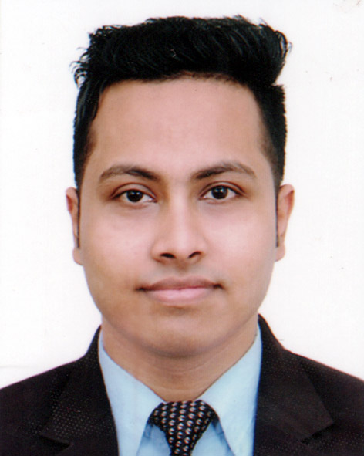
Curriculum Vitae
Saeed Hassan Tomal

Raj Mahal, Damia Villa, Maijpara,
Shamshernagar Road, Moulvibazar.
Mob: 01763-176647
Email: tomalhassan67@gmail.com

Career Objective

To seek challenging job competitive environment where my knowledge and ability can be utilized to yield the maximum benefit to the organization as well as myself and want to work as a dedicated, devoted, dynamic and energetic employee.

Educational Qualifications

LL.B. (Hon’s)
Session : 2012-13
Institution : Metropolitan University , Sylhet.
Result : CGPA-3.27
Year of Passing : 2017

Higher Secondary Certificate (H.S.C/Alim)
Name of Institution : Moulvibazar Govt. College.
Group : Humanities
Board : Sylhet
Result : GPA-5.00
Year of Passing : 2012

Secondary School Certificate (S.S.C/Dakhil)
Name of Institution : Moulvibazar Govt. High School
Group : Humanities
Board : Sylhet
Result : GPA-4.81
Year of Passing : 2010

Interests

Inquisitive about world affairs, watching TV News, Reading Books, Listening music, Playing & Traveling.

Personal Information

Applicant Name : Saeed Hassan Tomal
Father’s Name : Abdullah Afzal
Mother’s Name : Saleha Akther
Present Address : Raj Mahal, Damia Villa, Maijpara,
Shamshernagar Road, Moulvibazar.
Permanent Address : Raj Mahal, Damia Villa, Maijpara,
Shamshernagar Road, Moulvibazar.
Date of Birth : 22/01/1994
Marital Status : Unmarried
Religion : Islam
Gender : Male
Blood Group : O+ (ve)
Nationality : Bangladeshi

Experience

- 6 months Surveyor in Virtual Edge, Sylhet.
- I have experience in the Data Entry Assistant industry, Web research, Lead generation, Microsoft Excel, Microsoft Word, PowerPoint, Article, Portfolio.

Reference
A.S. Abdul Qadir Mahmud
Chairman
Unnayaon Shoyaok Songstha
Moulvibazar.
Mobile: 01714-000168
Adv Giash Uddin Ahmed
Lawyer, Judge Court
Moulvibazar
Mobile : 01711974297

I hereby declare that above statement are correct complete.



Signature: Saeed Hassan Tomal

Date :

