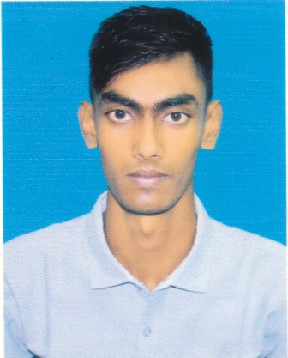
RESUME
OF
Sakin Howlader

Contract Address:

17,Narailpara,North Masimpur,Pirojpur,8500
Cell: 01816400800, 01856066655.
Email- sakinhawlader4@gmail.com

To develop a career in a renowned organization with a position that promises structural career advancement and opportunity to work in a broad spectrum providing ample scope to exercise creativity and analytical skills.
Objective:

Academic Profile

- HSC Examination

Institution : Aftabuddin college
Year of Passing : 2018
Group : Humanities
Result : 2.58
Board : Barishal Board.

- SSC Examination

Institution : Kiamuddin Secondary School
Year of Passing : 2016
Group : Humanities
Result : 3.00
Board : Barishal Board.

Communication skills in the following languages
Language Proficiency:

- Bengali : (As Native)
- English ( Medium)

Area of Interest:

Reading Books, Reading Newspaper, Travelling,
Sports, Music

- Strong motivation and commitment for work.
Interpersonal:

- Endurance to work for long hours and under pressure
- Ability to work independently as well as a team member.
- Commendable communication and presentation skill.

Personal Details:

- Name : Sakin Howlader
- Father’s Name : Md. Shahjahan Howlader
- Mother’s Name : Sabina Yasmin
- Permanent Address : Vill- 17,Narail para, P.O- Pirojpur,
P.S- Pirojpur, Dist- Pirojpur.
- Date of Birth : 5th October 1997
- Sex : Male
- Religion : Islam
- Nationality : Bangladeshi (by birth)
- Marital Status : Unmarried
- National Id No : 1501496101

- MS Office Word
Computer Skill:

- MS Office Access
- MS Office excel
- MS Office Power point
- Internet Browsing

3 Year’s Experience In Robi Axiata Ltd. As a Customer Service Officer.
Experience:

I certify that all information stated in this resume is true and complete to the best of my knowledge. I authorize to verify the information provided in this resume.
Certification:

Name : Md. Golam Mostofa
Reference:
Designation : Sales Manager

Organization : Robi Axiata ltd.
Pirojpur.
Mob : 01610002568

Name : Arijit Kumar Saha
Designation : Sales Manager

Organization : Robi Axiata ltd.
Manikgonj
Mob : 01817180579

Date: Signature

