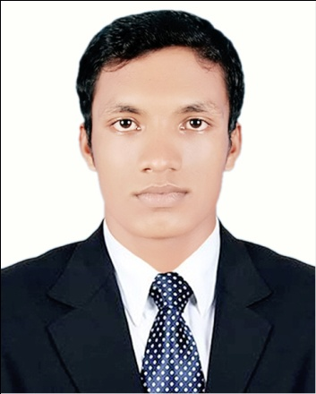


Nozrul Islam
Contact Address: House # 11, Road # 03, Block # C,
Banasree, Rampura, Dhaka-1219
Contact No: +8801956 249333
E-mail: saliemsovug786@gmail.com

Career objective:

To work in a challenging environment with a scope of future progress, applying my academic knowledge and working capability. I would like to welcome the chance to work as a part of a dynamic working team where I could make a significant contribution. Looking for a solutions oriented administrative position with notable success direction with a broad range of corporate business activities requiring challenging, analytical and organizational skills in direct support of business objectives.
Educational Qualification:

Bachelor of Social Science (B.S.S. Degree)

Institute : Shaid Suhrawardy College
Board : National University
Subject : Political Science
Session : 2012-2013
Result : 2nd Year (Running)

Higher Secondary Certificate (H.S.C)

Institute : Kafiluddin Degree College.
Result : G.P.A- 4.42 (Out of 5.00)
Grade : A
Board : Technical
Group : Business Management
Passing Year : 2012

Secondary School Certificate (S.S.C)

Institute : Jana Kallan Adarshaw High School
Result : G.P.A-3.50 (Out of 5.00)
Grade : A-
Board : Comilla
Group : Business Studies
Passing Year : 2010

Experience & Employment History:

- Project Name : Chitrali Digital Studio & Training Centre
Address : Chondrogonj Bazar, Begumgonj, Noakhali.
Name of Post : Computer Operator.
Duration : 1st April 2010 to 30th December 2012
Work : Photography

- Project Name : Buetech Computer
Address : House # 36, Road-01, Block-C,
Banasree, Dhaka-1219.
Name of Post : Computer Operator
Duration : 1st January 2013 to 30th December 2014.
Work : All kinds of Stationary Item, Photocopy, Lamination, Spiral Binding, Computer Compose,Color Print, Photo to Photo, E-mail, Scaning, Various Online Application Form Fillup, Passport Form Fillup, Visa Check, ID Card, Visiting Card, Leaflet, Festoon, Banner making available here.

- Project Name : Voice Tack Communication
Address : Nikunju-2, Khilkhat, Dhaka.
Name of Post : Data Entry Operator.
Duration : 1st January 2015 to 31th December 2015.

- Project Name : Enam Computer and Photocopy
Address : H-01, Block-D, Main Road, Banasree, Rampura, Dhaka.
Name of Post : Computer Operator.
Duration : 1st January 2016 to Still Now.
Work : All kinds of Stationary Item, Photocopy, Lamination, Spiral Binding, Computer Compose, Colour Print, Photo to Photo, E-mail, Scanning, Various Online Application Form Fill up, Passport Form Fill up, Visa Check, ID Card, Visiting Card, Leaflet, Festoon, Banner making available here.
Language Proficiency:

Bengali : Mother Tongue (Excellent)
English : Second Language (Good)
Self Appraisal:

- Honest and Punctual.
- Quick Learner.
- Excellent as a team member.
- Like to take the challenge.
- Friendly.

Computer Skill:

[

- Hardware assembling & Trouble shooting.
- Microsoft Office: MS Word, MS Excel, MS Power Point, Able to type both English and Bangla.
- Adobe Photoshop CS3.
- Adobe Illustrator CS3.
- Internet E-mail, Visa Check, Online All Application & Internet Browsing.
Communication Skill:

- Quite confident and friendly while meeting and assisting people at all levels and able to provide them with a quality service.
- Able to handle efficiently, courteously and tactfully clients directly or over the phone.

Personal Information:

- Name : Nozrul Islam
- Father’s Name : Tajul Islam
- Mother’s Name : Sefaly Begum
- Date of Birth : 10th February 1994
- Sex : Male
- Marital status : Unmarried
- Permanent Address: Vill- Karim Pur,P.O- Podipara Bazar,
P.S- Bugumgonj, Dist- Noakhali, Bangladesh.
- Home District : Noakhali
- Religion : Islam
- Nationality : Bangladeshi by Birth
- National ID No : 19947510712000092
- Height : $5^{'}-6^{''}$
- Weight : 59 Kg
- Blood group : B+

Declaration:

I certify that, to the best of my knowledge and belief, this “CV” correctly describes my qualification and me. My willful misstatement described herein may lead to my disqualification or dismissal if admitted.


Date: 02.04.2019 Signature

