Curriculum Vitae t
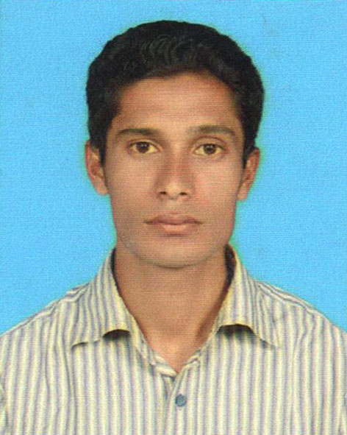
of
Salim Ahmed

Carieer Objectives: To utulize theoritical Knowledge for sustainable depending on present and future need. To work in an institute and prove the potentiality through hard work, effciency, enthusiasm and integrity.

Exteem traits: A Drive to perform patience, accepting challenging work, willingness to tearn.

Personal Information:

.
- Name : Salim Ahmed
- Father's Name : Abdul Khalik
- Mother's Name : Rokaia Begum
- Date of Birth : 24-12-1994
- Religion : Islam
- Marital Status : Unmarried
- Nationality : Bangladeshi
- Sex : Male
- Contact No : 01674-478118
- E-mail : ahmedsalim01616@gmail.com
- Permanent Address : Vill: Lalpur, Post: Sunamganj, Up: Sunamganj Sadar, Dist: Sunamganj
- Present Address : Vill: Kucharpara, Mohona Block-D, House- No: 23/2, Sylhet Sadar

- Educational Qualification:

Name of Exam | Passing year/ Session | GPA | Group | Board/ University
Dakhil | 2010 | 4.06 | Genaral | Madrasah
Alim | 2012 | 3.75 | Genaral | Madrasah
Honours | Running | - | Economic | mc

I Certify that all information stated in this Curriculum Vitae is true and completed to the best of my knowledge. I authorize the respective authoruty to verify the information provided in this Curriculum Vitae.

Yours Sincerely

Signature

Salim Ahmed

