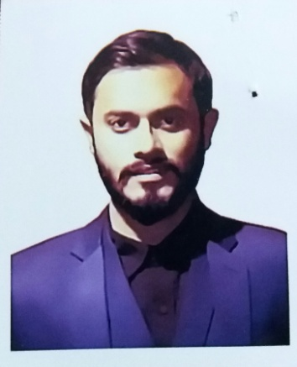
Samin Irtiza Nahid

Contact Address : House no: 13/11, Subidbazar, Sylhet
Cell : +8801781420559
Email : irtiza193@gmail.com
Career Objective:
Aim to work creatively in a competitive & challenging environment with strong responsibility & commitment where job satisfaction and career development will be provided. I want to develop myself as an honest, hard working and efficient person.
Academic Qualifications:
Bachelor of Business Administration (B.B.A)
Year of Passing : 11th semester running
Result : 3.20
Institute : Metropolitan University, Sylhet
Higher Secondary Certificate (H.S.C)
Year of Passing : 2014
Group : Business studies (COMMERCE)
Result : 3.70
Board : Sylhet
Institute : Sylhet khajanchibari International School & College,Sylhet

Secondary School Certificate:
Year of Passing : 2012
Group : Business studies (COMMERCE)
Result : 4.81
Board : Sylhet
Institution : SCHOLARSHOME

Computer Literacy:
Operating System : MS. Word, MS. Excel, MS. Power Point, & Internet Browsing, Tally & Factura

Communication Skill:
Bangla (Mother Language) : Excellent both in speaking and writing.
English : Good at both in speaking and writing.

Personal Attributes
    - Strong academic background
    - Self-confident & positive
    - Ability to work efficiently under pressure & meeting deadlines
    - Ability to work in teams & maintain effective communication
    - Optimistic
Personal information
Father’s name : MOHAMMED KHURSHED ALAM BARO BHOUYAN  Mother’s name : MRS.NAZMA ALAM  Permanent Address : Nurani 13/11,subid bazar,sylhet.  Date of birth : 06/12/1993  Religion : Islam  Marital status : Single | Height : 5”4  Blood group : B+  Nationality : Bangladeshi  National ID No : 2399706536  Mobile : 01781420559
References:
MD MASUD RANA  Assistant Professor  Head,dept.of Business Administration  Metropolitan University  Email: mrana@metrouni.edu.bd  Cell : 017110692291 | DR.MOHAMMAD JAMAL UDDIN  Assistant Professor  Metropolitan University  Email: muddin@metrouni.edu.bd  Cell: 01680264028

Declaration

I, the undersigned declare that the information specified in this Resume is true to the best of my belief and knowledge and correctly describes my experience and myself.

Samin Irtiza Nahid

