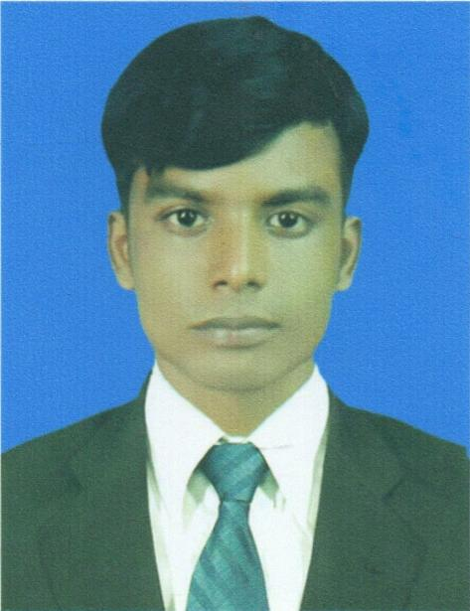
Resume Of
SAMRAT HOSSAIN

Address: Mirpur 1,Dhaka 1216
Cell Phone: 01892707323
Career objective.

Being a self-motivated and hardworking personality I am searching a job where I can provide my creativity to explore my ability and sincerity to the responsibilities of the job in a sound working place as I have the experience of a multinational environment as well.

Name of Exam. | : Bachelor of Business Administration
Institution | : Sonargaon University.
Year of  Admison | :08-08-2018
Year completed | : Running...

Name of Exam. | : Higher Secondary School Certificate (H.S.C)
Institution | :Khalilue Rahman Degree College.
Year of passing | : 2014
Result | : 2.80 out of 5.00
Group | : Business Studies
Board | : Dhaka.

Name of Exam. | : Secondary School Certificate (S.S.C)
Institution | : Bashtoil M M High School
Year of passing | : 2012
Result | : 3.06 out of 5.00
Group | : : Business Studies
Board | : Dhaka.

Computer Skill

- Operating System: Windows XP, Windows 7,Windows 10
- Microsoft Office
- Microsoft Excel
- Internet Browsing
- E-mail

Language Proficiency

Good command in Bengali and English (Written & Oral).

Strength

- Honest & Sincere to work
- Dynamic & Self Motivated
- Hard working & have the cope with people of all level.

hOBBY

Playing Cricket, Football, Chess and Badminton
- Travelling
- Nobel
- Listening Music
- Watching TV& You Tube

Presonal information

Father’s Name | : Abdus Samad
Mother’s Name | : Nurzahan Begum
Date of Birth | :1 0-10-1994
Nationality | : Bangladeshi by birth
Religion | : Islam
Marital Status | : Single
NID No | : 19949316687000184
Sex | : Male
Height | : 5.7’
Permanent Address | : Vill:Tarafpur, Post: Tarafpur,  Thana: Mirzapur, Dist: Tangail.

EXPERIENCE

➤ Pran-Rfl Group. ( Sales Representative)

➤ Bkash Limited ( MDO)

_________
Signature

