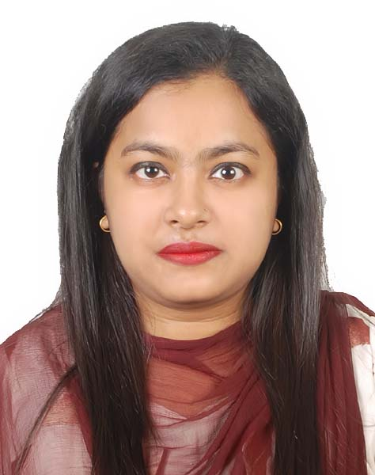Resume
of
SANJIDA RAHMAN
Mobile No: +8801846556313
Email: shanjida.israt11@gmail.com

- CAREER OBJECTIVE:

To build up career in a responsible in Position in national or multinational organization where my talent and knowledge will significant to organization target achievement.

- EDUCATION QUALIFICATION:

- Bachelor of Science (BSc)
Name of Institution : Daffodil International University (DIU)
University : Daffodil International University (DIU)
Subject : CSE
Result : CGPA-3.34 (Out of 4.00)
Passing Year : 2020

- Higher Secondary Certificate (H.S.C)
Name of Institution : Shaheed Bir Uttam Lt.Anwar Girls’ College
Board : Dhaka
Group : Science
Year of Passing : 2015
Result : GPA-3.70 (Out of 5.00)

- Secondary School Certificate (S.S.C)
Name of Institution : Dhaka Shiksha Board Laboratory School & College
Board : Dhaka
Group : Science
Year of Passing : 2012
Result : GPA-5.00 (Out of 5.00)

- COMPUTER LITERACY EXTRA

Name of Organization
- M.S Word, M.S Excel, M.S Power Point, Internet Browsing Etc.
- Works Training.

- PERSONAL QUALITIES:

- Creative, innovative, cultural minded and like to face challenges.
- Comfortable in working under pressure
- Excelling, administration, interpersonal and communication skills.
- Professional attitude & discharging responsibilities.
- Familiar with C++ Java.

- LANGUAGE PROFICIENCY:

- Excellent skills in speaking, reading, writing and listening in both Bengali and English.

- PERSONAL DETAILS:

Full Name : Sanjida Rahman
Father’s Name : Habibur Rahman
Mother’s Name : Maryna Rahman
Date of Birth : 11/05/1997
Permanent Address : House-31/20,14E Road-northpaikpara,
Paikpara. Postoffice: Mirpur T SO
Dhaka-1216.
Present Address : House-31/20,14E Road-northpaikpara,
Paikpara. Postoffice: Mirpur T SO
Dhaka-1216
Blood Group : O+
Marital Status : Unmarried
Nationality : Bangladeshi
Sex : Female
Religion : Islam
Contact Number : 01846556313
NID No. : 6902308656

- DECLARATION:

I hereby submit my curriculum vitae in which the content is true the best of my knowledge.


Signature

