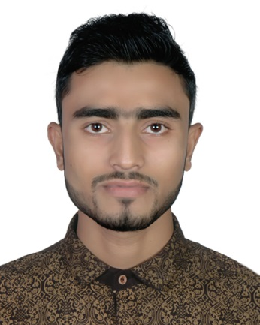
CURRICULUM VITAE

Of

MD. SAZZADUR RAHMAN

C/O:MD. Belal Uddin

Vill: Harishpur, P.O: Chhatak, P.S: Chhatak,

Dist: Sunamgonj

Phone: 01757-683932

E-Mail: srrumen@gmail.com

Career Objective

I want to be an energetic, dynamic and efficient part of your organization by developing my technical and managerial skill with sincerity and honesty.

Academic Qualification
M.S.S (Masters) in Political Science
- Institution : MC College, Sylhet
- Faculty : Political science
- Academic Session : 2016-17
- Result : Expecting

B.S.S (Hon’s) in Political Science
- Institution : Madan Mohan College, Sylhet
- Faculty : Political science
- Academic Session : 2012-13
- Result : CGPA 2.72 ( In the scale of 4.00)

H.S.C (Higher Secondary School Certificate)

- Institution : Chhatak Degree College, Chhatak, Sunamgonj
- Group : Business Studies
- Academic Session : 2010-2011
- Year of Passing : 2012
- Result : GPA 3.90 (In the Scale of 5.00)

S.S.C (Secondary School Certificate)

- Institution : Chhatak Cement Factory High School,
Chhatak, Sunamgonj
- Group : Business Studies
- Academic Session : 2008-2009
- Year of Passing : 2010
- Result : GPA 4.38 (In the Scale of 5.00)

Computer Literacy
- PhotoshopCC16, Graphics design basic
- Windows Set Up
- Internet Browsing and E-Mailing.
- MS Word, MS Excel, MS Access, MS Power Point

Language and Communication Skills

- Bangali : Mother Language. Proficient in reading and writing
- English : Proficiency in reading, writing and speaking.

Extra-Curriculum Activities
- Reading Poetry, Short Story, Novel and Feature
- Playing Football, Cricket, Badminton, and the Chess.

My Ability
- Confident in my honesty.
- Mind set to work hard in difficult situation.
- Capacity to develop new idea.
- Eager to learn new things.
- Deep communication knowledge.
- Good interpersonal and communication skills.

Experience
Position : M.P.O
Company : GACO Pharmaceuticals Ltd.
Durations : June 2017 to October 2018.

Position : Manager
Company : Aporupa Cosmetics
Durations : August 2012 to April 2017.

Hobbies
Traveling, Reading of Books, Playing of Various games and Sports, & Coordinating of Program

Personal Details
- Father’s Name : Md. Belal Uddin
- Mother’s Name : Mst. Henu Begum
- Date of Birth :15th December /1994
- Nationality : Bangladeshi by Birth
- Sex : Male
- Marital Status : Single
- Religion : Islam
- NID card no : 19949022306000026
- Blood Group : AB+
- Home District : Sunamgonj
- Permanent Address : Vill: Harishpur, Chhatak Sunamganj .
- Present Address : 30/1, Rajbari, Shahi Eidgha,
Sylhet City Corporation.

I do hereby declare that the information stated above is correct to the best of my knowledge.

MD. SAZZADUR RAHMAN
Date: 28-02-2020

