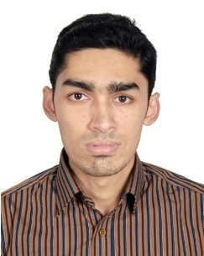
Md. Shahriar Chowdhury
Address: B-16 Bilpar, Lamabazar, Sylhet. 3100
Mobile : 01675-638355
E-mail : riazchy44@gmail.com

Career Objective:

Seeking a challenging career with progressive organization offering prospect to demonstrate and argument my skill, where seemliness of work provides job satisfaction and the place of work provide potential avenues for learning and growing.

Career Summary:

- Good customer focuses approach.
- Good interpersonal negotiation skills.
- Capable of doing work with tight deadline.
- Strong Communication Skill (Presentation, Public speaking etc).
- Good team worker.
- Can work creative, self-initiative skills.
- Strong analytical ability.

Academic qualification:

Bachelor of Business Administration (BBA)
Year: 2016
CGPA: 2.59 in scale of 4
Major in Marketing.
Leading University, Sylhet

Higher Secondary Certificate (HSC)
Year: 2011
GPA 4.10 in scale of 5.00
Group: Business Studies
Scholarshome, Sylhet

Secondary School Certificate (SSC)
Year: 2009
GPA 4.31 in scale of 5.00
Group: Science
Shahjalal Jamia Islamia School & College, Sylhet

LANGUAGE SKILLS
Have good command over Bengali and English both oral and written.

COMPUTER SKILLS
Application Software - MS Office Package Program (MS Word, MS Power point, MS Excel.) familiar with the use of e-mail as well as internet browsing.

PERSONAL INFORMATION
Father's Name | : | Md Abdul Hannan Chowdhury
Mother's Name | : | Helena Begum
Date of Birth | : | October 26, 1992
Gender | : | Male
Marital Status | : | Unmarried
Nationality | : | Bangladeshi
National Id No. | : | 19929196211000053
Religion | : | Islam
Permanent Address | : | B-16 Bilpar, Lamabazar, Sylhet. 3100

Reference:
Shahed Mahmud  FAVP & Manager  Fenchuganj Branch  Eastern Bank Limited  Cell no: 01714-000732 | Md. Abdul Muhith Chowdhury  Senior Lecturer  Department of Business Administration  Leading university  Mobile – 01911-528681
I do hereby declare that particulars provided above are true and no misinformation is given.

Yours Truly

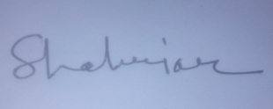
…………………………...
Md. Shahriar Chowdhury

