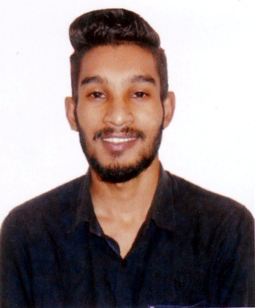
Resume Of
Md. Shahriar Hossen
Cell: 01712-043598
Address: Latif Hall, North Bagunbari, Tejgaon I/A, Dhaka-1208
Cell- +8801719657550

Career Objective:

I would like to work with the Organization. Provide the potential through, hard work & efficiency & also like to work in a challenging environment, with the preference of result oriented work.

Educational Qualification:

Diploma in Institution : Dhaka Polytechnic Institute
Engineering Discipline : Civil Engineering
Session : 2014-15
Result : 2.49 (out of 4.00)
Board : Bangladesh Technical Education
Board (BTEB)

S.S.C Institution : Rajpasha High School
Discipline : Science
Result : GPA 4.13 (out of 5.00)
Passing Year : 2014
Board : Barishal

Computer Skill:
- Software : MS-Word, MS-Excel, MS-Power Point.
- Expert : Internet & Web Browsing.

Language Skill:

Language | Reading | Writing | Speaking
Bengali | Fluent | Fluent | Fluent
English | Fluent | Fluent | Social

Personal Information:

Father’s Name : Late. Md. Habibur Rahman
Mother’s Name : Samsunnahar
Permanent Address : Vill: Rajpasha, P.O: Rajpasha
P.S: Bhandaria, Dist: Pirojpur
Date of Birth : 02/12/1998
Marital Status : Unmarried
Sex : Male
Religion : Islam
Nationality : Bangladeshi by birth.
Height : 5.8’’

Declaration:
I am confirming that all the information I have given in this resume is true and updated.

Signature

Md. Shahriar Hossen

