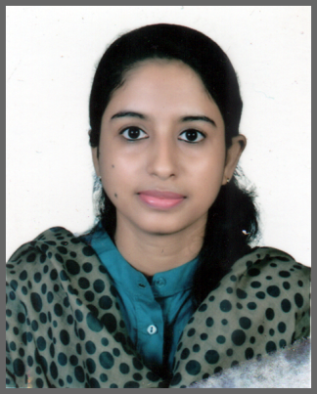
Resume
Of
Shalina Begum
Address: 24 Jalalabad R/A, Amberkhana, Sylhet.
Contact No: 01758-923111
Email: shalinaela1971@gmail.com

Career objective:

To work in a challenging and dynamic environment and keep adding value to the organization that I represent and serve, while also currently upgrading my skill and knowledge.

Academic Qualification:
Name of Examination | Institution Name | Board | Year | Result
Bachelor of Art’s (English) | Leading University, Sylhet. | Leading University, Sylhet. | 2019 | Appeared
Higher School Certificate | Sylhet Govt. Women’s College, Sylhet. | Sylhet | 2012 | GPA 4.30
Secondary School Certificate | A.G.I High School, Sylhet | Sylhet | 2010 | GPA 4.38

Professional Experience:

- Worked as a English Spoken Teacher at Bangladesh Youth Development Training Centre from 2016 to 2017.

Individual Skill:

- IELTS Band Score: 5.5
- Can converse in English and Bangla language
- Good communication and presentation skill.

Computer Proficiency:

- Proficiency in Microsoft Word & Windows.

Personal Information:

Father’s Name : Late Aman Uddin Ahmed
Mother’s Name : Rabeya Begum
Date of Birth : 3rd June, 1994
Permanent Address : Vill: Amkuna, P.O: Asirgonj Bazar, P.S: Golapgonj, Dist: Sylhet.
Blood Group : A⁺

--------------------------
Applicant Signature

