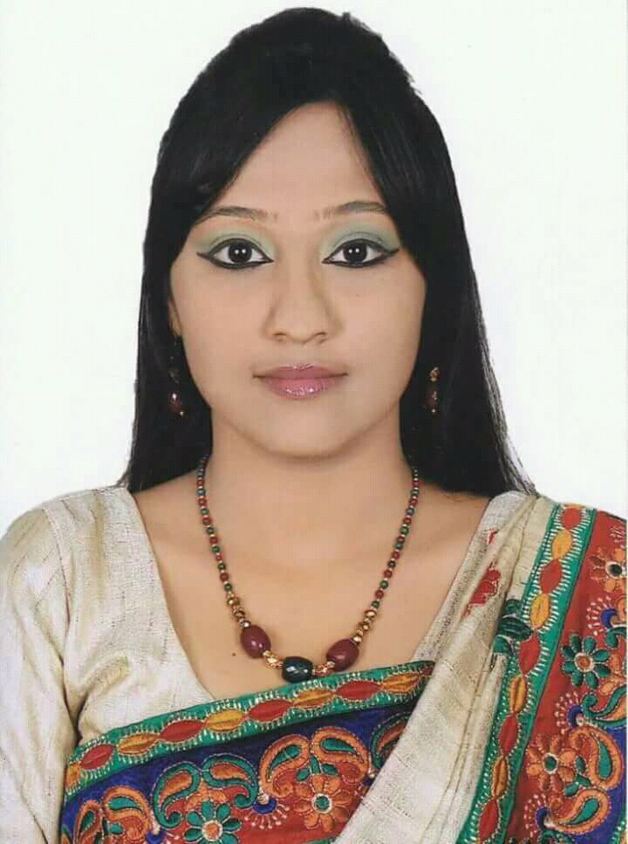
Shamantha Ghose
22/A, Rajar Goli, Dargah Gate, Sylhet, Bangladesh
Email: shamanthaghose3@gmail.com , Cell : +8801789548121

Objective
To build a career in well reputed organizations offering suitable positions and having proper job responsibilities which offer challenging tasks and wide scope of reward in each achievement. I am eager to acquire the highest performance according to my ability and opportunity provided by appropriate work environment and adequate scope where I can apply my creative skills and competencies to enhance organization image.
Educational qualification
LL.M (2019): (Pursuing), Metropolitan University,Sylhet,Bangladesh.
LL.B (2018): (2.61 out of 4.00), Premier University,Chittagong,Bangladesh.
H.S.C (2012): (4.20 out of 5.00), Chittagong Mohila College
S.S.C (2010): (4.25 out of 5.00), Chittagong Aparna Charan City Corporation Girls’ High School
Computer Skill
Office Application : Microsoft Office - 2007, 2013
Internet Application: Microsoft Internet explorer & all types of internet activities
Languages Efficiency
English : Speaking – Fluent, Writing – Very Good, Listening – Good
Bangla : Speaking – Fluent, Writing – Very Good, Listening – Fluent
Extracurricular Activities
- Performed recitation in Chittagong Television (CTV) in 2017.
- Performed as a voice artist in a short film “EK CUP LOBON CHA”
- Engaged as Reciter for 3 years in “SWARANANADAN”
- Engaged as Theatre Worker for 1 year in ‘’ACADEMY OF PERFORMING ARTS” & “DARPAN THEATRE, SYLHET”
- Workshop On Law Career Development: Department of Law & Justice in Metropolitan University, Sylhet
- Workshop on TV news presentation & FM Radio (RJ) from “NANDONIK, Bangladesh”
- Workshop on Film Appreciation from “REBEL ANT”
- The Network For International Law Students Workshop On Career Opportunity: way to thriving legal industry in Chittagong University
- Engaged in Cultural Event Management Of “SUPROBHAT BANGLADESH”
- Engaged in brand awareness activities of “UNILIVER BANGLADESH”
- Awarded in Independence day art competition organized by “Intraco CNG”
- Engaged as debator in a debating club “PANTHAJAN”
- Completed community level volunteer training programme from “Fire Service & Civil Defense, Bangladesh”
Personal Information
Father’s Name : Bikash Ranjan Ghose
Mother’s Name : Gopa Ghose
Date of Birth : 20th April, 1995
Birth Place : Chittagong, Bangladesh
Permanent Address : 22/A, Rajar Goli, Dargah, Sylhet, Bangladesh
Present Address : 22/A, Rajar Goli, Dargah, Sylhet, Bangladesh
Nationality : Bangladeshi by birth
Gender : Female
Religion : Hindu
Marital Status : Unmarried
Blood Group : O+(ve)

Reference
Advocate Sanjoy Biswas (LL.M) Advocate B.N. Ghosh
Assistant Professor Judge’s Court, Sylhet
Department of Law of Premier University Email: ghoshbiswanath216@gmail.com
Chittagong, Bangladesh Cell: +8801711-380229
Income Tax Practitioner (I.T.P)
Email: sanjoy.law@gmail.com
Cell: +8801716-566539

Certification
I certify that, these data correctly describe about my qualifications, my experiences and me. I understand that any willful misstatement described herein may lead to my disqualification to the opportunity.

Signature Date: 01-09-2019
