Name : Shampa Rani Das

Fother’s Name : Nitish Das

Mother’s Name : Arpana Das

Permanent Address : Halder Para,Surma:9,Sylhet

Present Address : Halder Para,Surma:9,Sylhet

Cantact Number : 01761996859

Date Of Birth : 05/11/1995

ACADEMIC Result:

Name of exzamination | Grade | Year
SSC | 4.25 | 2011
HSC | 3.90 | 2013
HONOURS | 2.95 | 2018
MASTERS | Running | 2019-2020

Signature
Date : / /

-----------------------------------------------------

PERSONAL INFORMATION
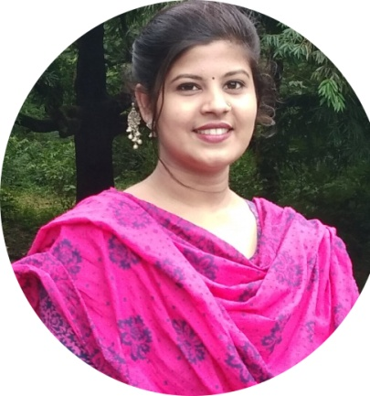
MASTERS
NORTH EAST UNIVERSITY BANGLADESH: NEUB
Shampa Rani Das
Good Speaker
English Literature
NORTH EAST UNIVERSITY BANGLADESH: NEUB

2020- 2019
BORDER GUARD PUBLIC SCHOOL & COLLEGE,SYLHET
SCHOLARSHOME GIRLS COLLEGE
English Literature

HIGHER STUDIES
shamparanidas89@gmail.com
ABOUT ME
CAREER OBJECTIVE
Date of Birth: November 05, 1995
Age: 24
Gender: Female
Birth Place: Sylhet
Hard-working professional with proven communication, creative thinking, and multitasking skills. Aiming to leverage my abilities to successfully fill the Teaching role at your organization. Frequently praised as efficient by my peers, I can be relied upon to help your organization achieve its goals.
CONTACT
ACADEMIC BACKGROUND
SKILLS
EXPERTISE
INTERESTS
Halder Para,Surma:9,Sylhet Bnagladesh Sylhet, Sylhet, 3100
01761996859
2018 -
2014
2013 -
2012
2011 -
2010
HONOURS

HSC
Business Studies
SSC
Science

Attentive Listening and Effective
Oral Communication Skills
Great at Problem Solving
Ability to Quickly Create and
Apply Ideas and Solutions
Good Leadership Skills
Critical Thinker
English Graduate
Private Teacher
Singer

