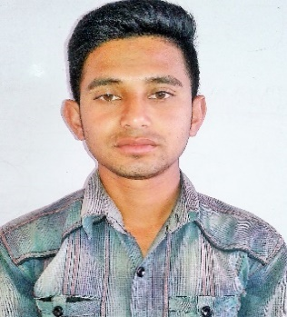
CURRICULUM VITAE
Shapon Ahmed
Address:palashifatipur
P.S: Bagha,P.O: Bagha
Dist: Rajshahi (6280)
E-mail:shaponahmed342@gmail.com
Mob: 01768816927
CARRIER OBJECTIVE:
To prove myself as a quick learner and highly energetic person to face any mission critical and technical operations by involving me in the main stream operations of the organization.
PERSONAL INFORMATION:
- Name : Shapon Ahmed
- Father’s : Md Nabu Mandol
- Mother’s : Nabirjan Khatun
- Permanent Address:
Village : Palashi fatepur
P.O : Bagha
P.S : Bagha
Dist : Rajshahi (6280)
5.Present Address :
Village : Talbaria
P.O : Talbaria
P.S : Kotwali
Dist : Jashore (7400)
6.Date of Birth : 12/08/1998 (by birth)
7.National ID Number: 19988111035000086
8.Nationality : Bangladeshi(by birth)
9.Religion : Islam(Sunni)
10.Marital Status : Unmarried
11.Height : 5-3”
12.weight. : 52 kg
13.Blood Group : A⁺
14.Sex : Male
15.Mobile : 01768816927
Accademic Profile
Secodary School Certificate
Name of School | Chakrajapur High School
Name of board | Rajshahi
Group | Science
Passing Year | 2014
Result (GPA) | 4.81
Diploma Engineering
Name of Institute | Jessore Polytechnic Institute
Name of board | Dhaka
Department | Electrical
Passing Year | 2018
Result (CGPA) | 2.77
Extra Exparience :
Course Name | Institute Name | Sassion | Duration
1.Computer office Application | Imperial Institute of Technology | January-June 2018 | 6 Months
2.Electrical House Waring | Technical Training Center | January-June 2018 | 6 Months
3.Refrizaration & Air Conditionaring | department of youth development | July-December 2017 | 6 Months
4.Basic Electronics |  | January-June 2017 | 6 Months
5. Solar Home System | Technical Training Center | July-December 2018 | 6 Months
6. Mobile Servicings | department of youth development | May-July 2018 | 3 Months
7.Industrial Attachment | department of youth development | January-June 2018 | 6 Months

06.04.2019 shapon
Date........ Signature………….

