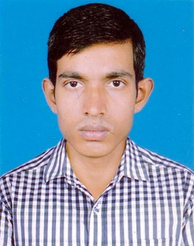
CURRICULUM VITAE
of

MD. SHARIFUL ISLAM

Cell: 01763-217979

Career Objective:
Intend to work in a challenging and competitive environment where strong sense of responsibility and commitment are required, work potential avenues, for learning and growing to achieve my position in hierarchy of any sector.

Academic Qualification:

M.A (Masters)
Year of Passing : 2017
Institution : Satkhira Govt. College, Satkhira
University : National University
Subject : Bangla
Result : CGPA- 3.22 (Out of 4.00)

B.A (Honours)
Year of Passing : 2016
Institution : Satkhira Govt. College, Satkhira
University : National University
Subject : Bangla
Result : CGPA- 3.18 (Out of 4.00)

Higher Secondary Certificate
Year of Passing : 2012
Institution : Dathvanga Mohabiddaloy
Board : Jessore Board
Group : Humanities
Result : GPA- 4.30 (Out of 5.00)

Secondary School Certificate
Year of Passing : 2010
Institution : B K Union High School
Board : Jessore Board
Group : Humanities
Result : GPA- 4.19 (Out of 5.00)

Personal Information:

Name : Md. Shariful Islam
Father’s Name : Md. Abdur Rahman
Mother’s Name : Mst. Sahiba Khatun
Present Address : Village: Ghona, Post Office: Ghona-9400
Upazila: Satkhira Sadar, District: Satkhira
Permanent Address : Village: Ghona, Post Office: Ghona-9400
Upazila: Satkhira Sadar, District: Satkhira
Date of Birth : 11/10/1994
Nationality : Bangladeshi (by Birth)
Religion : Islam
Marital Status : Unmarried
Sex : Male
National ID No : 5096965362
Blood Group : A+
Height : 5 Fit 5 Inch

Training
Organization Name | Post Name | Day
Bangladesh Insurance Academy | Insurance Agent | 06 Day

Computer Course:
Ms Word, Ms Excel, Ms PowerPoint, Internet etc.
Personal Hobbies:
Traveling, Sports, Reading Novels & Story books.
Language:
Bengali, English.

Signature

....................................
Md. Shariful Islam

Date:

