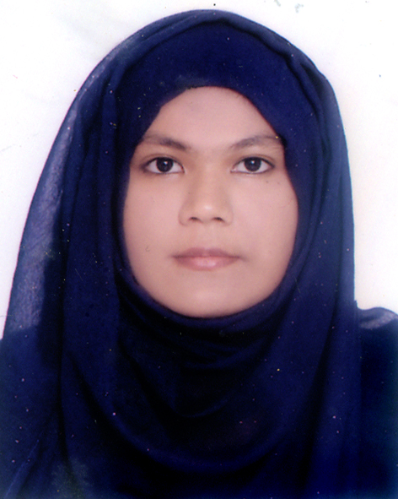
Resume of
Sharmin Sultana Jhouty
Ghilachora house,Muhammadpur,Mejortila,Sylhet.
Email: jhoutysharmin@gmail.com

ACADEMIC QUALIFICATION:

- B.S.S. in Social work

Shahjalal University of Science and Technology, Sylhet.

Session: 2014-15.
Result: CGPA – 3.24 out of 4.00

- Higher Secondary Certificate (H.S.C) in Science Group (2013)

Jalalabad Cantonment Public School & College,Sylhet.
Result: GPA – 5.00 out of 5.00

- Secondary School Certificate (S.S.C.) in Science Group (2011)

Khalil Chowdhury Adarsha Bidya Niketon.
Beanibazar, Sylhet.

Result: GPA – 5.00 out of 5.00

Other Qualification:
Field work in Sarkari Shishu Paribar,Raynogor,Sylhet.

LANGUAGE SKILL:

Spoken and written communication skills in both English and Bengali.

COMPUTER SKILL:
Ms word,Power pont

(Familiar with Internet application and E-mail)

PERSONAL INFORMATION:

Name | : Sharmin Sultana Jhouty
Father’s Name | : Md. Omar Faruk
Mother’s Name | : Husnara Begum
Permanent Address | : Village: Gojukata, Post Office: Dubagbazar, Upazilla: Beanibazar
 |  | District: Sylhet.
Date of Birth | : 22 April 1995.
Nationality | : Bangladeshi (By Birth)
Blood group | : B (+ve)
Contact no: 01623911302

_________________

