Curriculum Vitae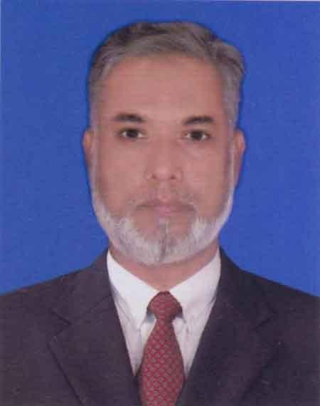
Of
Md. Shawkat Ahmed Khan
Cell : 01777368835
E-mail : shawkatk10@gmail.com

Career Objective:
As a self motivated, hard working, high ambitious and energetic youth. I would like to build up a challenging Career in right sector under extreme pressure where have opportunities to work, grow professionally and Take responsibilities.
Scholastic Attainment:
Name of Exam | Board/University | Year of passing | Division | Name of School/College
B. Com( pass) | Under DU | 1987 | Third | Dhaka City College
H.S.C | Dhaka | 1984 | Second | Dr. Shahidullah College
S.S.C | Dhaka | 1981 | Second | Rifles Public School

Professional Employment: (Working Experience):
1. Name of company: Tejpata Restaurant and Tejpata Cafe.
- Type of business: Restaurant (Continental, fast food, Thai, Indian, Cafe, bangla party service.
- Location: Dhaka , Bangla Motor
- Designation : Manager cum chef activity.
- Working Period : From 1.10.2017 to till now.2018 .
- Responsibilities: Restaurant Operation, Customer relationship, customer Services, Cash management, Purchase, Marketing, Party booking, advertisement, stock requirement, stock inventory, Raw materials stocking, Daily sales report /statement, sales inventory, chef activities (Continental and fast food), Kitchen staff and service staff training, Kitchen management, cleanliness, hygiene, all purpose equipment checking and maintenance, Cooking, menu price costing, food costing, staff schedule preparations, salary sheet preparations, Daily budget, Daily requisition as per Kitchen order, Hot & cold beverages department after looking etc.
2. Name of company: Full Stop Lounge and Restaurant.
- Type of business: Restaurant (Continental, fast food, Thai, Indian, Cafe, bangla party service.
- Location: Gazipur Sadar.
- Designation : Manager cum chef activity.
- Working Period : From 10.10.2013 to 31.07.2017 (Total-3.10 years.)
- Responsibilities: Restaurant Operation, Customer relationship, customer Services, Cash management, Purchase, Marketing, Party booking, advertisement, stock requirement, stock inventory, Raw materials stocking, Daily sales report /statement, sales inventory, chef activities (Continental and fast food), Kitchen staff and service staff training, Kitchen management, cleanliness, hygiene, all purpose equipment checking and maintenance, Cooking, menu price costing, food costing, staff schedule preparations, salary sheet preparations, Daily budget, Daily requisition as per Kitchen order, Hot & cold beverages department after looking etc.

3 . Name of company: Butterfly Park (BD) Ltd.
- Type of business: Restaurant, Resort (Continental, fast foal, Bangla party)
- Location: Patenga, Chittagong.
- Designation: Manager Cum Chef activity.
- Working Period : From 01.09.2011 to 30.09.2013 (Total-2 years.)
- Responsibilities: Restaurant Operation, Customer relationship, customer Services, Cash management, Purchase, Marketing, Party booking, advertisement, stock requirement, stock inventory, Raw materials stocking, Daily sales report /statement, sales inventory, chef activities (Continental and fast food), Kitchen staff and service staff training, Kitchen management, cleanliness, hygiene, all purpose equipment checking and maintenance, Cooking, menu price costing, food costing, staff schedule preparations, salary sheet preparations, Daily budget, Daily requisition as per Kitchen order, Hot & cold beverages department after looking etc.
4. Name of Company : Chicken King Int. (BD) Ltd. (Malaysian Franchises,)
- Type of business : Fast food Restaurant. (International)
- Location: Uttara Branch, Dhaka
- Designation : Brauch Manage cum chef activity.
- Working Period : 01.09.2003 to 31.07.2011 (Total = 7 years 10 months)
- Responsibilities: Restaurant Operation, Customer relationship, customer Services, Cash management, Purchase, Marketing, Party booking, advertisement, stock requirement, stock inventory, Raw materials stocking, Daily sales report /statement, sales inventory, chef activities (Continental and fast food), Kitchen staff and service staff training, Kitchen management, cleanliness, hygiene, all purpose equipment checking and maintenance, Cooking, menu price costing, food costing, staff schedule preparations, salary sheet preparations, Daily budget, Daily requisition as per Kitchen order, Hot & cold beverages department after looking etc.
5. Name of company: Kontor House (Germany)
- Type of business: Italian Restaurant.
- Location: Germany (Sehlesvieg Holstein)
- Designation :Head Chef (Continental)
- Working Period : From 01.11.1991 to 24.05.1998 (Total- 6 years 7 months)
- Responsibilities : Chef activities, Cooking, Various Salad preparation, Pizza making, pasta, BBQ & Grill, Sauces, salad dressing, confectionery items, Hot & cold beverages, Buffet & Catering, Cleanliness, Hygiene, Daily stock inventory, Raw material stocking, kitchen equipment maintenance, staff training, Daily sales inventory. LIFO, FIFO System as per production, Daily requisition as per food production, opening and closing schedule preparation as per duty rooster etc.

6. Professional Training :
1. Name of institute : Vocational trading School (Real Schule)
Type of Training : Food & beverage Production and presentation (cooking)
Location : Germany, Kappeln.
Training Duration = 1 year (01.11.1991 to 1.11.1992)
Training Role/subject : Fast food, continental food, Pizza, Pasta, BBQ &Grill, Sauces, Dressing, cakes, biscuits, Birthday Cake, Moose, Food costing, Hygiene, Cleanliness, Food Freezing as per LIFO-FIFO System, Food Production as Per KOT, Hot & Cold dishes.
2. Name of Company: Western Institute of Business and Technology.
Type of training : International Hotel Management Course (Food and Beverage Production, Cooking.)
Location : Dhaka, Bangladesh.
Training Duration : 1 years (2007)
Training Subject : Fast-food, Continental, Bangla, Indian, Thai, Chinese, Tandoori , Hot & cold beverages, Dessert.
Extra skills:
1. Computer Application course, DUET, Dhaka, Since 1999.
2. Language ability: Bangla, English, Hindi, Germany.
3. Upcoming restaurant- Set up (A to Z) Solution.

Personal Details:
Name: Md Shawkat Ahmed Khan.
Father’s name : Late Omar Ali Khan.
Mother’s name: Late Rizia Begum.
Present & Permanent Address: D-150/4, Middle Chayabithi, Joydebpur, Gazipur -1700.
Date of birth: 02/02/1965 Age:
Height: 5’-7 ½’’
Religion: Islam (sunni).
Marital Status: Married.
Sex : Male.
Blood Group: AB+
Nationality: Bangladesh(By Birth).
National ID. NO: 3323004135407.
Under the circumstance it is therefore, prayed and hoped that you would kind enough to consider my application and appoint me in the post prayed for. I shall try my best perform my duties the utmost satisfaction of the authority.
Thanking you best Yours faithfully

Dated: ( Shawkat Ahmed Khan)
Cell. Nr: 01777368835/01882671311

