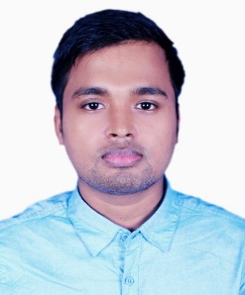

Resume
Shawon Chowdhury
Cell :01731871127
Email: shawonchowdhury966@gmail.com

Career Objective

To Work in a professional environment where there is an opportunity for self-assessment and self-improvement in both individual and group based activities for facing critical challenges with devoting integrity.

Educational Background

B.B A(Honors) : National University
BBA 4th (Running )

Higher Secondary Certificate : (H.S.C) :
Madan Mohan College, Sylhet.
GPA 4.10 On Scale of 5.00
Group: Business Studies; Year of passing: 2014

Secondary School Certificate : (S.S.C) :
The Aided High School, Sylhet.
GPA 3.50 on Scale of 5.00
Group: Business Studies; year of passing: 2012

Language Skills

Proficiency in writing, reading, speaking and listening of both Bengali and English.

Computer Skills
Application Software : Microsoft Word, Excel, Power Point
Others Skills: Digital marketing, Graphic

Personal Details

Name : Shawon Chowdhury
Father’s Name : Joyanta Chowdhury
Mother’s Name : Jhunu Chowdhury
Permanent Address : Subhanighat, Moubon-10 (A/13), Sylhet.
Present Address : Subhanighat, Moubon-10 (A/13), Sylhet.
Nationality : Bangladeshi
Religion : Hindu
Date of Birth : 28-09-1996
Marital Status : Unmarried
Mobile : 01731871127

