Shekh MD. Golam Shahriya  Computer Science Engineer | 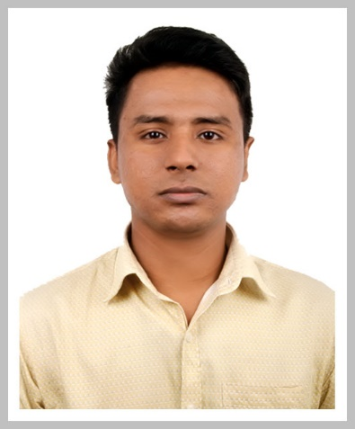
Address: 5B, Chowdhury Villa, DAG- 285, Ashkona, Uttara, Dhaka
Phone no: 01681680599
Email: ullashshahriar@gmail.com

Career Objective:
To work in an organization where culture of freedom and working for initiatives is ensured, facilitating my contribution through thoughts and action to the company’s vision and thus achieve self-development by playing a significant role in building the organization.

Special Qualification:
BSc engineering in computer science
Bangladesh Army International university of science and technology

Duties/Responsibilities (basic):
My key responsibilities include
o C programming
o C++ Object oriented programming
o Android studio apps developing(one course for project)
o Game developing course(80 hours course)

Duties/Responsibilities (professionally):
1.HTML5
2.CSS3
3.Bootstrap-4
4.JavaScript
5.jQuery
6.AngularJS

Academic Qualification:
Exam Title | Concentration/Major | Institute | Result | Pass. Year | Duration | Achievement
BSC engineering | Computer science | Bangladesh Army International University of Science and Technology | CGPA:3.36  out of 4 | Running | 4 Years | Running
H.S.C | Science | Cumilla Victoria govt. college | CGPA:4.40  out of 5 | 2014 | 2 Years | Higher Secondary Certificate
Dakhil | Science | Hajiganj Alia Madrasah | CGPA:5.00  out of 5 | 2011 | 10 years | Secondary School Certificate

Training Summary:
Training Title | Topic | Institute | Country | Location | Year | Duration
Game development and idea share | Game create | Bangladesh Army International University of Science and Technology | Bangladesh | Cumilla | 2016 | 80 hours

Specialization:
Fields of Specialization | Description
Computer Science and Engineering | Programming IDE  O Code Blocks  Technical Skills  o Platforms- Windows 7, 8 ,10 Linux (partially)

Extra Curricular Activities:
o. Video editing in Filmora
o. Microsoft Word, Microsoft PowerPoint , Microsoft Excel

PERSONAL INTERESTS & EXPERIENCE in Codding Thinking and Motivated self and other

Learning progress on:
1. JSON
2. ASP.NET CORE

Complete project : Online food order management system (spicy food house)

Language Proficiency:
Language | Reading | Writing | Speaking
Bengali | High | High | High
English | Good | Very Good | Very Good

Personal Details :
Father's Name | : | Md. Sheikh Abdur Rahim
Mother's Name | : | Sajeda Begum
Date of Birth | : | January 1, 1996
Gender | : | Male
Marital Status | : | Single
Nationality | : | Bangladeshi
National Id No. | : | 7347640083
Religion | : | Muslim
Permanent Address | : | Dopalla, Waruk Bazar, Shahrasti, Chandpur-3620, Bangladesh.
Current Location | : | Cumilla

