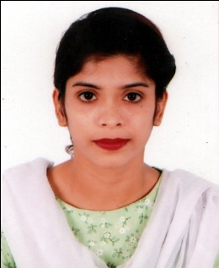
Curriculum Vitae

SHIRIN AKHTER
Borobazar-03 Amborkana Sylhet
Mobile: 01733-424995

Career Objective

Searching for a desirable opportunity with which I will have the scope in utilizing my skills and potentiality to do something innovative for the people and from which I will be able to enhance my knowledge and efficiency.

Educational Qualifications

Masters of Business Administration (M.B.A)
Institute : Leading University
Subject : Finance & Banking
Passing Year : 2018
Result : CGPA- 3.77
Bachelor of Business Administration (B.B.A-Hons)
Institute : Metropolitan University
Subject : Finance & Banking
Passing Year : 2017
Result : CGPA- 3.54
Higher Secondary Certificate (H.S.C)
Institute : Narishikkha Academy
Board : Sylhet
Passing Year : 2013
Group : Business Studies
Result : GPA- 4.00
Secondary School Certificate (S.S.C)
Institute : Barlekha Girls High School
Board : Sylhet
Passing Year : 2011
Group : Humanities
Result : GPA- 3.06

Experience

Sales Representative at Sylhet Online Shop.
Intern at Social Islami Bank Limited Barlekha Branch, Sylhet.

Computer Skills

Graphics Design, Web Design, MS Word, MS Excel, MS PowerPoint, Internet Browsing etc.

Language Skills

Fluent speaking, writing and listening in Bengali, English and Hindi.

Hobby

Watching movie, Reading book, Playing Cricket and Football, Traveling.

Personal Details

Name : Shirin Akhter
Father’s Name : Abdul Latif
Mother’s Name : Jeli Begum
Date of Birth : 10-01-1994
Permanent Address : Mohodikuna, Barlekha moulvibazar Sylhet
Gender : Female
Nationality : Bangladeshi
Marital Status : Unmarried

References

Jamal Uddin
Md. Aminur Rahman
Executive Officer Of NCC Bank Barlekha Branch, Sylhet
Mobile: 01819839109

Mobile: 01714-506159

Department Head of Business Administration
Metropolitan University, Sylhet
Mobile: 01571-733803

Declaration

I confirm that all information stated in this curriculum vitae is accurate and complete to the best of my knowledge. I also authorize the respective authority to verify the information provided in this curriculum vitae.

Signature & Date

