Introductory Data | Md.Shofiqul Islam
 | Address | House No.17/1,North Adabor,Dhaka 1207.
 | Mobile | +8801722762173
 | E-Mail | shofiqulislam2509@gmail.com
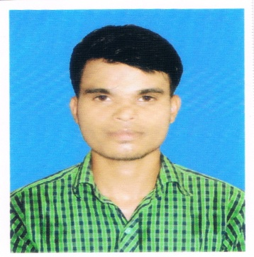

Career Objective
Looking forward to build up my career in software development where I have the opportunity of upgrading my knowledge about the newest advancements as well as utilize my expertise at developing software to be a valuable team player.

Project Works

- Issue Tracker – For organizing Task as a project work for the fulfillment of BASIS OOP training using C# and SQL.
- “Warehouse Management System” as a project work for the fulfillment of BASIS OOP training Using ASP .Net and C#.
- “Library Management System” as a project of “Object Oriented Programming and Analysis” course using Java and MySql.
- “Hospital Management System” as a Project of “Software Engineering” course using Java and MySql
- “Chat Server” as a project of “Computer Network” using Java.

Technical Skill and Knowledge

Programming Language: C, C++, C# and Java ( J2SE and familiar with J2EE).
Scripting Language: HTML, CSS, JavaScript PHP.
Database: MySql, Oracle.
Operating System: Linux, Microsoft Windows (Server/Professional)
Networking: Practical experience of establishing, configuring and maintaining LAN.

Work Experience
(Auto Cad,3D-Max)1 Year

Educational Profile
Exam | Board/University | Subject/Group | Year of Passing | CGPA
S S C | Madrasha, Board | Humanities | 2014 | 3.44
Diploma | DIST | Civil | 2018 | Appeared

Personal skill
Highly self motivated and energetic, quick learner, strong communication ability with other people.
Language Proficiency

Have fluency in Bengali and English both in oral and written form.

Personal Details

Father’s Name : Md.Khairul Islam
Mother’s Name : Mst.Sufia Khatun
Permanent Address : Vill:Runia,P.O:.Singul,P.S:Biral,Dist:Dinajpur.

Marital Status : Unmarried
Date of Birth : 05-04-1994.
Religion : Islam.
Nationality : Bangladeshi.

References
Profess. Bac.Md.Saidur Rahaman Department of Mathematic Contact No: +8801925090712

BAC.Md.Tahmid Ahmed Department of Head Of Civil Contact No: +8801734600927

I certify that the statement made above is correct.

…………………………………….
Signature
(Md. Shofiqul Islam)

