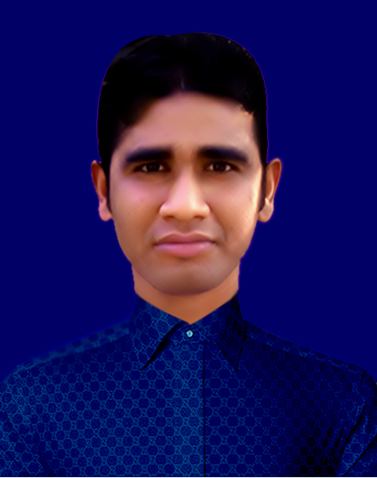 MD:SHORIFUL GAZI
Mailing Address:
Rupsha Brize,Darogarlich,Raypara,Khulna.
Khulna, Bangladesh.
Mobile Number: +8801963-993138
Career Objective :
+8801963-479780
E-mail:-mdbnsgazi@gmail.com
To secure a worthy position in a premium organization where I can apply my expertise on branding, product marketing, customer relation and monitoring to effect the future growth of the organization.
Academic Qualification :

Secondary School Certificate (Vocational)
Group : Mechanical Technology
Institution : UCEP Mohasin Khulna Technical School .
Board : BTEB
Year of Passing : 2017
Result : GPA-4.96
Junior School Certificate
Group : Humanities
Institution : Boyra Secondary School.
Board : Jessore
Year of Passing : 2014
Result : GPA-4.11
Working Experience:

Operation System : Windows XP -2010,Windows-7,10
Application Package : MS Office (Microsoft Word, Excel,
Power Point) Photoshop Basics Hardware,
Web Application : E-mail, Internet Browsing.
Language Proficiency:

Bengali : Mother Language
English : Reading, Writing & Speaking
Personal Information:

Name : Md:Shoriful Gazi
Father’s Name : Md.Lutfor Rhman Gazi
Mother’s Name : Saleha Begum
Present address : Hazi Ismail Road, Sonadanga, Khulna.
Permanent Address : Village:Amtola, Post:Soturopa
Thana:Koyra, District:Khulna,
Date of birth :10th-July-1997
Sex : Male
Home District : Khulna
Nationality : Bangladeshi (By Birth)
Birth Registration No : 19974798518024592
Marital Status : Umarried
Religion : Islam(Sunni)
Blood Group : (A+)
Weight : 53Kg
Height : 5^{ft}-4”
Declaration:
:

I hereby declare that I Information provided in this form complete and correct to the best of my knowledge.
Md:Shoriful Gazi

Signature

Date:…../….../……

