

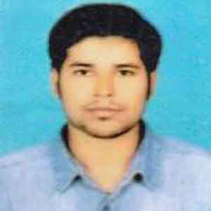
Education
Seeking for position which will prepare me to take on many roles as an innovator, a talent developer, a problem solver, and above all a business researcher by utilizing my skills abilities and educational accomplishment that will enhance Professional growth while being resourceful,Innovative and leader.

Objectives

Internet Browse
MS powerPoint
MS Excel
MS Word
Technical:
- Elevated inter-personal skills and motivational qualities achieved
- Through industrious, proactive participation in academic and extra academic activities.
- Presentation & persuasion skills
- Fluency in English and Bengali
- Good communication skill and very good team leader.

Interpersonal:
MD. SOHEL RANA
Contact: 01771-889667
Email: shohagrana01912@gmail.com

Personal Information:

Father’s Name:
Md. Abdul Latif
Mother’s Name:
Most. Selina Khatun
Date of Birth: 19.09.1994
Religion: Islam
Sex: Male
Marital Status: Single
Nationality: Bangladeshi
NID: 6004737687
Permanent:
Vill: Notun Para Salanga, P.O: Salanga, Thana: Salanga, Dist: Sirajgonj

Member of Associations:
- Member of Badhon (Blood Donating Org.)

University : North Bengal International University
Major : Sociology
Result : CGPA-3.46(out of 4.00)
Passing Year : 2019

University : North Bengal International University
Major : Sociology
Result : Regular

H.S.C
S.S.C
Board : Rajshahi
Result : GPA-3.94 (out of 5)
Group : Science
Passing Year : 2010

Skills
Board : Rajshahi
Result : GPA-4.63 (out of 5)
Group : Business Studies
Passing Year : 2015

B.S.S
M.S.S
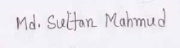
Reference
Dr. Azizul Alam
Professor
Dept. of Sociology
North Bengal International University.
Contact No: +88001774596428

Hobbies:
- Travelling
- Reading
- Photography
- Debating
- Acting

Additional Degree:

Six Month Certificate Course on Microsoft Office Word, Microsoft Office Excel, Microsoft PowerPoint.

Experience:
- NASHA Group (Gazipur) as Trainee Officer(Q.I).

Declaration

I hereby declare that the above written particulars are true to the best of my knowledge and belief.

Md. Sohel Rana

