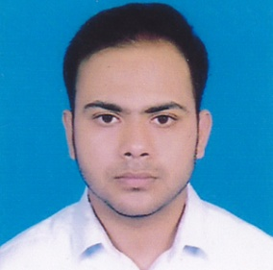
Resume
of
Solayman Islam Rahat

MAILING ADDRESS:
Solayman Islam Rahat
Mohakhali, DOHS,
R- 31, H - 469 , F – A2
Tejgaon, Dhaka-1215
Email: solaymani26@gmail.com
Cell: 01626-379522

CAREER OBJECTIVE:
To obtain a growth oriented job in a reputed institution that provides a fully professional working environment & good opportunity to develop an excellent career.

ACADEMIC BACKGROUND:

Bachelor of Business Arts (Hon’s)

University : National University
Institute : Tejgaon University
Department : Marketing
Running Year : 4th year

Higher Secondary Certificate (H.S.C)

College : Al Amin Academy School And College
Group : Business Studies
Passing year : 2015
Result : 3.41 out of 5.00
Board : Comilla

Secondary School Certificate(S.S.C)

School : Al Aamin Academy School And College
Group : Business Studies
Passing Year : 2013
Result : 4.88 out of 5.00
Board : Comilla

LANGUAGE & HOBBIES:

Language : English & Bengali.

PERMANENT ADDRESS:

Village : Palbazar, Bakultala Road .
Post Office : Chandpur Sadar .
Police Station : Chandpur .
District : Chandpur.

PERSONAL INFORMATION:

Name : Solayman Islam Rahat
Father’s Name : Nazrul Islam
Mother’s Name : Hamida Islam
Date of Birth : 21st September 1996
Sex : Male.
Nationality : Bangladeshi (by birth)
Marital Status : Single.
Religion : Islam.
Palace of Birth : Chandpur.

COMPUTER SKILL:
Computer Operating System: Windows 7, 8, 10.
Application Package: M/S Word, Excel, Power Point.
WORKING EXPERIENCE:

- I have been worked as a Sales Executive in robiaxiata ltd. of 3 Month.
- I have been worked as a Sales Executive in MilvikBima of 6 Month.
- I have been worked as a D.S.O in Bkash of 1 Year.
- I have been worked as a Check Out Assistant (POS) in Shwapno of 1 Year.
- I have been worked as a Sales Executive in Gadget & Gear of 1 Year.
- I have been worked as a Executive, Accounts & Finance in Akashbari Holidays of 1 Year.

(Solayman Islam Rahat)

