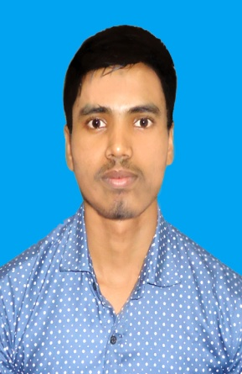
CURRICULUM VITAE OF SUJOY BISWAS

Mailing Address:
Bijoy Shoroni
Farmgate,Dhaka.
Email: biswas01988691804@gmail.com
Call: 01771586309
Career Objective
To pursue a work by which I can serve by using my vision, positive attitude, interpersonal relationship, communication skill to take the challenge that will also ensure me the opportunity to grow by learning new skills and knowledge as well as develop your institution.

Academic Certification

B.S.S (Hon’s) Political Science
Institution Name :Govt Titumir College
Result :1st Year Running
Session :2017-2018
University :Under Dhaka University

Higher Secondary Certificate (H.S.C)
Institution Name : Shahid Smriti College, Shashikar.
Group :Humanities
Result :GPA-3.83
Passing year :2017
Board :Dhaka.

Computer Literacy
Application Software :MS Office (MS Word, MS Excel, MS PowerPoint, MS Access)
Other :Internet Browsing

Personal Information

Name :Sujoy Biswas
Father’s Name : Manoranjan Biswas
Mother’s Name :Manikya Biswas
Permanent Address :Vill - Lakhanda, P.O - Lakhanda
Thana-Rajoir, Dist-Madaripur
Date of Birth :25-May,2000
Nationality :Bangladeshi (by birth)
Religion :Hindhu
Marital Status :Single
Gender :Male
Blood Group :B+(Positive)
Height :5’.6”
Weight :57 kg

Language Proficiency

Bangali (Excellent Reading, Writing & Speaking)
English (Good Reading, Writing & Speaking)

Personal Strengths
- Industrious
- Excellent Communication capacity.
- Motivating, Leading & Convincing power.
- Like Serving people

Hobbies
Traveling, photography, Gardening, Enjoying Movies.

Declarations
I the undersigned certify that according to my knowledge and belief, this CV correctly describes my qualification, my experience and myself. I understand that any willful misstatement here may lead to my disqualification.

.................................
Date:…………… SujoyBiswas

