Sumiya Rahman Tasnim
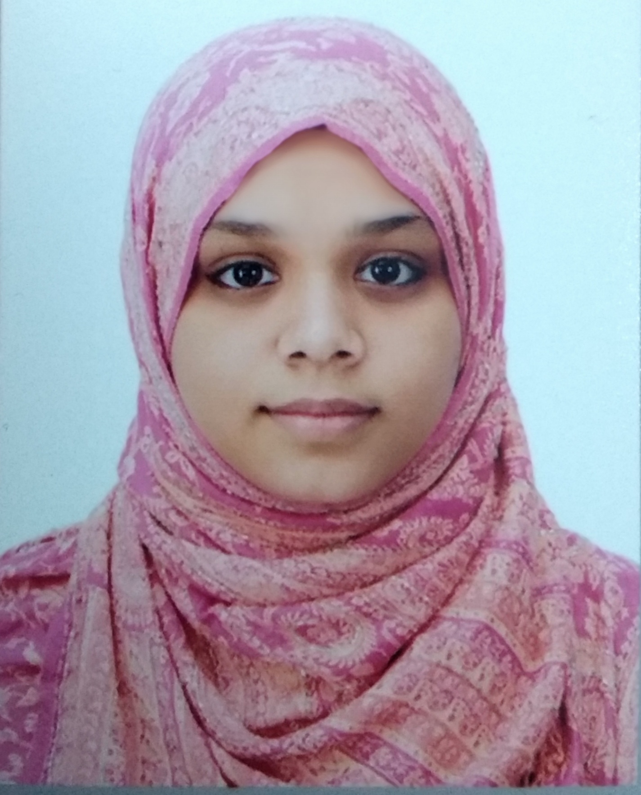
81 ,Modhushohid,Sylhet
Mobile:(+88)01860509622
Email :srtasnim420 @ gmail.com
Career objective
I am studying in Metropolitan University, currently looking for a job in any junior position of any company or institution. I would like to utilise my skills and theoretical learning as well as my passion. Moreover ,I would like to work with other professional to improve my skills as an employee with allow me to father contribute in the field of profession.
Working Experience
3 month internship in Shahjalal Islami Bank Limited, Sylhet branch, Sylhet
Educational Background
Master of business Administration(M.B.A) Metropolitan University Sylhet
Academic year : 2018 to 2019
Current position: Last semester student
Major : Finance and banking
Bachelor of Business Administration (B.B.A)Metropolitan University, Sylhet.
Academic year : 2014 to 2017
Passing year : 2018
Major : Finance and Banking
Results :2.87(4.00)
High school certificate (H.S.C)Commerce College Sylhet
Academic year : 2011 - 2012
Passing year :2013
Major :Business Studies
Results :4.30(5.00)
Secondary school certificate (S.S.C)Police Line High School ,sylhet
Academic year : 2009 - 2010
Passing year :2011
Major :Business Studies
Results :4.19(5.00)
Personal information
Full Name :Sumiya Rahman Tasnim
Father Name :Md.Habibur Rahman
Mother Name :Shamima Sultana
Present Address / Permanent Address :81,Modhushohid ,Sylhet
Date of Birth : November,10,1994
Marital Status :Unmarried
Nationality : Bangladeshi
Religion : Islam
Interest :Reading Book of Islamic scholars watching , Lectures on YouTube, Travelling ,Social networking , Creating handmade products and Recycle etc.
Software Skills
Microsoft Word , Microsoft Excel , PowerPoint
Language and communication skill
Efficient both in English and Bangla,Good listener, Efficient of both worlds verbal and nonverbal communication, Friendliness.
Personality
Communicative, Creativity, Friendly, Organised and Punctuality.
Certification
Certificate in basic computer application
Duration :3 months
Institute : National Youth Development training centre, chowhatta, sylhet.
Reference
Prof.Dr. Tahir Bilal Khalifa Mohammed Fazlur Rabb Tanvir
Dean,Scholar School of Business and Economics. Register
Metropolitan University,Sylhet Metropolitan University sylhet
Mobile : 01711969525 Mobile :01712856442
Declaration of Authenticity
I do there by declare that ,all the information stated above are true to my knowledge and if required I can provied all the information.

Sumiya Rahman Tasnim

