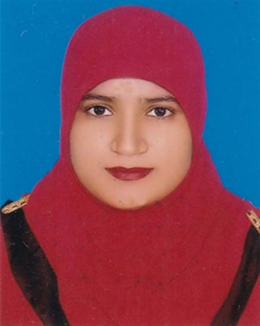
Resume of
Srabony Islam
Mailing address
Nimshar, Burichang , Comilla.
Contact Number: 01729710058
G-mail: srabonyislam523@gmail.com

Searching for a desirable internee with whom I will have the scope in utilizing my skills and potentiality to do something innovative and challenging works and from where I will be able to enhance my knowledge and efficiency.

Career objectives

Career Summery
A position in corporate procurement in the retail industry that can utilize five years of negotiating and research skills and eventually lead to a management-level role.

Education Qualification

MBA ( Master of Business Administration )
Tongi Govt. College
Major- Management
Result: Appeared
Passing Year- Appeared

BBA ( Bachelor of Business Administration )
National University
Major- Management
Result: CGPA-3.12 (Out of 4)
Passing Year- 2016

Higher Secondary Certificate (HSC)
Narayangonj Govt. Mohila College.
Dhaka Board
Passing Year: - 2012
Group- Business Studies
Result: 4.00 out of 5.00

Secondary School Certificate (SSC)
Fatullah Pilot High School.
Dhaka Board
Passing Year: - 2010
Group: - Business Studies
Result: - 4.31 out of 5.00

Language Proficiency | Writing | Speaking | Listening
Bangla | Excellent | Excellent | Excellent
English | Good | Good | Good

Computer Literacy
Platforms: - 2000, XP, Vista, Win 7, Win 8,

Skills
Good Command over – Microsoft office, Internet browsing,
Partially computer hardware.

Personal Profile
- Name : Srabony Islam
- Date of Birth : August 08, 1994
- Gender : Female
- Father’s Name : Sirajul Islam
- Mother’s Name : Hawa Begum
- Nationality : Bangladeshi by birth
- Religion : Islam
- Marital Status : Unmarried
- Present address : Nimshar, Burichang , Comilla.

- Permanent address : Vill: Dapa Idrakpur
P.O. Fatullah
P.S. Fatullah
Dist: Narayangonj

Personal Interests
Traveling and Listening Music.

1) Organization: Dhaka Mission School, Nimshar Branch.
Worked as Assistant Teacher and Hostel Super Since 01 January 2018 to till now.
Employment History
Responsibilities: Teaching Secondary level of students. and take care of Hostel students

2) Organization: Unique Education Center
Worked as Assistant Teacher Since June 01 2015 to December 30 ,2017
Responsibilities: Teaching Secondary level of students.

3) Organization: Al Hikmah Ideal Academy
Worked as Assistant Teacher Since June 01 2014 to June 30 ,2015
Responsibilities: Teaching Secondary level of students.

Declaration of Authenticity

I do hereby declare that all information have presented are true to my knowledge, if require and where applicable, these statement can be supported by appropriate authentic papers.

Srabony Islam

