Curriculum Vitae
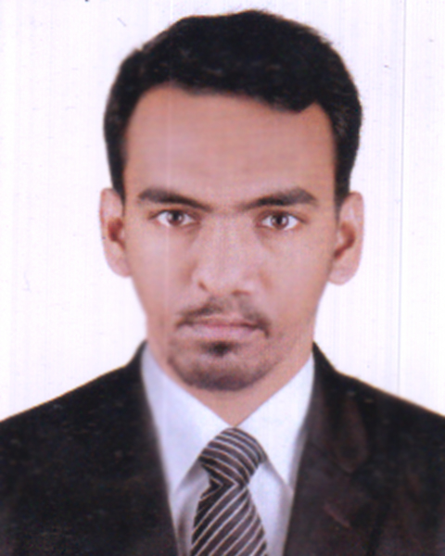
Of
Syed Ilias Ali
Cell: 01710715268
E-mail: syedhamdan60@gmail.com
Career Objective
Rendering of conceptual and organizational skills along with creativity, dynamism, enthusiasm and thus making position in corporate world. Moreover, enhancing and developing individual skill through all out efforts as well.
Personal Details
Father’s Name : Syed Iftekhar Ali.
Mother’s Name : Dilara Khanam Chowdhury.
Present &
Permanent Address : Vill. & P.O.:Usmanpur P.S.:Osmani Nagar, Dist.: Sylhet,
Bangladesh.
Date of Birth : 10 August 1991
Nationality : Bangladeshi
Religion : Islam
Marital Status : Unmarried
Blood Group : B+
Gender : Male
Height : 5’11’.
Academic Qualifications:
Graduation | Bachelor of Business Administration  Passing Year: 2017  Major: Human Resource Management (HRM)  CGPA: 2.81on a 4.00- Point Scale  Leading University, Sylhet
H.S.C | Higher Secondary Certificate Examination  Passing Year: 2010  Group: Humanities  Board: Sylhet  Result: GPA 2.60 on a 5.00- Point Scale  Institution: Madan Mahan College, Sylhet
Diploma in Business Management | Incomplete  Year : 2011  Institution; Crown International College  Brigstock Road, Thornton Health  Surrey, UK
S.S.C | Passing Year: 2008  Group: Humanities  Board: Sylhet  Result: GPA 3.00 on a 5.00- Point Scale  Institution: M.C.N.K High School, Sylhet
Language Proficiency
Bengali (Mother Tongue)
English (Fluent in Speaking, reading, writing & listening)
IELTS (Standard)
Score : 6.0
Sylhety Dialect (Local language)
Computer Literacy
Office Applications-MS Word, MS Excel, Power Point, Web Browsing
Activities
Logistic officer of ICC t20 World Cup 2014 in Sylhet. Acting treasurer at Youth Stuff, Sylhet. Volunteer of Sylhet Blood Donations Organization. Member of LU Band Community.
References
Md.Golam Muhit Rajib  Senior Officer  Rupali Bank Ltd.  Azimganj branch, Moulvibazar.  Mob: 01722-463264 | Syed Monirul Haque Rahat  Marketing Manager  Myanmar, Nepal and Bangladesh.  GlaxoSmithKline Bangladesh Ltd.  Gulshan-1, Dhaka.  Email: syed.m.rahat@gsk.com

