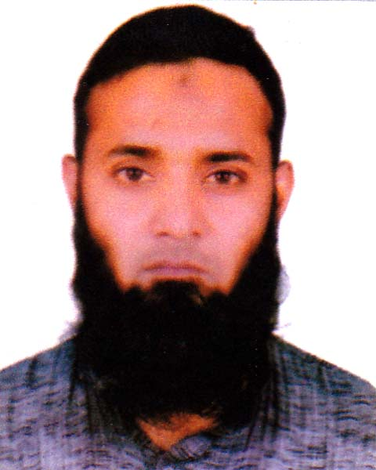
Syed Kamran Hassan
Mobile: 01718-045662, 01923-338229
E-mail: syedkamran241@gmail.com
OBJECTIVE
To build up a carrier in a challenging environment with excellent carrier development prospect, where hard work, strict discipline, good communications skill & creative problem solving are the comer stone of success.

Work
Before Work
ACI Godrey Agrovet Pvt. Ltd.

Now Work
Silver Tread Corporation
Electrician (2019- To Till Date)
Experience- 5 Years.

Electrical solar system. IPS & UPS connection, to perform 3-phase and single-phase line connection. Electrical wiring and perform to establishing motor control panel. 3-phase & 1-phase motor re-winding or servicing

EDUCATION

Technical Education
Satkhira Pollimongol High School & College, Satkhira.
Duration : 1 Years
Level/Trade: Electrician
Grade: A+

General Education
Satkhira P.N High School and College, Satkhira.
Duration: 8 Years
Exam : Class x
SKILL
• Motor Control
• 3- Phase & 1 Phase connection
• Timer & Relay Connection
• Magnetic Conductor
• CCTV Camera System
• Walkie Talkie Servicing & Program Install
• Access control System Setting
• Electrical Wiring
• Plumber Knows
• PA system
• House wiring

PERSONAL INFORMATION

Name : Syed Kamran Hassan
Father’s Name : Late. Syed Yousuf
Mother’s Name : Asma-ul-Fatma
Date of Birth : 12 November, 1987
Religion : Islam
Marital Status : Married
Present Address : 11 No khilji road Shymoli Dhaka-1207.
Permanent Address : Vill: Dhakula, PO: Ellcher, PS: Satkhira, Dist: Satkhira.

Signature of Applicant

