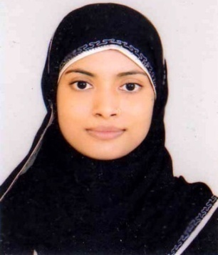
Curriculum Vitae Of
TAMANNA BEGUM
Address: House no-50/A, Pollabi Pathantula, Sylhet-3100.
Mobile no: +8801717542973
Email-tamannabegum86@gmail.com

Statement of Purpose:
To work in a challenging business environment and to excel in all assignments in professional career so as to mark a meaningful contribution to the competitiveness and value of the organization at large and in the process enhancement skills and knowledge.
Academic Qualification:

Bachelor of Business Administration [MBA]
Education Institution : Metropolitan University, Sylhet, Bangladesh
Duration : 1 Years
Year of Completion : 2016
Subject : Major in “Management”
Result : Appeared
Bachelor of Business Administration [BBA]
Education Institution : Metropolitan University, Sylhet, Bangladesh
Duration : 4 Years
Year of Completion : 2015
Subject : Major in “Management”
Result : CGPA 2.71 out of 4.00

Higher secondary certificate [HSC]
Education Institution : Scholars Home School & college, Sylhet
Duration : 2 Years
Year of completion : 2011
Group : Business Studies
Result : GPA 3.80 out of 5.00

Secondary School Certificate [SSC]
Education Institution : Hazrat Shahporan High School, Barlekha, Sylhet
Duration : 2 Years
Year of completion : 2009
Group : Business studies
Result : GPA 4.44 out of 5.00

Key Skills & Expertise;
- Experience in customer care, interacting with all customers and colleagues well.
- Excellent problem-solving skills and a diligent follower of policies & procedures.
- Confident in communicating and presenting at all levels.
- Remarkable patience with reliability and responsibility.
- A quick learner with high level of motivation.
- Experienced at working under pressure, remaining calm and professional of all times.

Employment History:

Internship three month (September 06, 2015 to December 06, 2015)
Southeast Bank Limited
Company Location: Pathantula, Sylhet.
Duties / Responsibilities:
Acquiring monthly target of Account Opening, DPS FDR and Internal branch customer services (Such as, Front desk customer service and Remittance Delivery).
Computer Proficiency:
Have working knowledge on Microsoft Word, Excel Power point , Windows 98,XP & Vista and good command at internet and able to operate different type of software’s.
Language Proficiency:

Excellent Communication Skills in Bangla and English both written and verbal.
Personal Details:
Name : Tamanna Begum
Father’s Name : Kalik Miah
Mother’s Name : Aleya Begum
Date of Birth : 28 June 1993
Gender : Female
Marital Status : Married
Nationality : Bangladeshi
Religion : Islam
Permanent Address : 50/A Pollabi, Pathantula, Sylhet-3100

Reference

Mohammed Jamal Uddin  Associate Professor( PHD Fellow)  Head in Charge.  Dept Of Business Administration  Metropolitan University, Sylhet.  Phone:01558347255 | Amjad Hussain  Vice President & Head of Branch  Southeast Bank  Pathantula, Sylhet.  Contact No: 0821724300

Tamanna Begum

